General tips for the Task below.
Task Title
Autoscaling Groups
Objective
Worked on pre-requisite, as I watched the Autoscaling groups posted in DevOps group in slack and task to work on below.
Prerequisites
List all requirements before starting:
- AWS
Issues Faced: Briefly mention issues and how you fixed them. Posted below in the last.
Conclusion
Conclusion has been provided for every task at the end.

Autoscaling Groups Tasks

- Create one VPC in N. Virginia region.
Objective:
VPC- Virtual Private Cloud. VPC is a core component of aws and it is an isolated private network and we can customize the private IP’s and we can manage our services.
Prerequisites:
• AWS Console
• VPC
• CIDR
• Region
Step by Step implementation:
Step 1: In browser, navigate to aws and sign in to console.
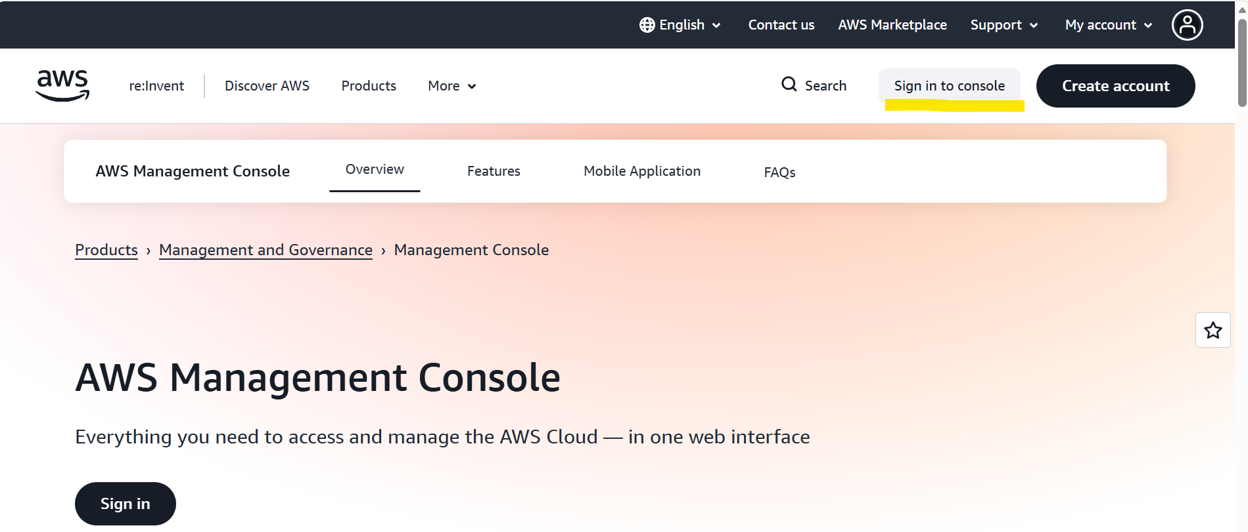
Step 2: Navigate to VPC and select VPCs.
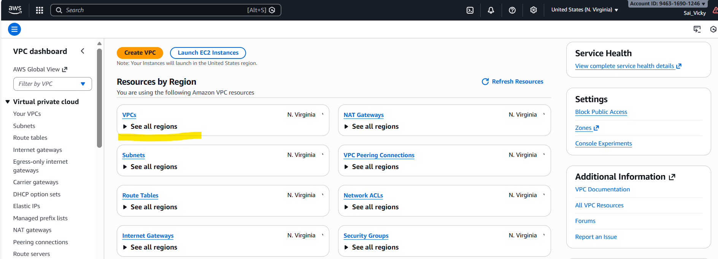
Step 3: Create a tag with name and provide CIDR range.
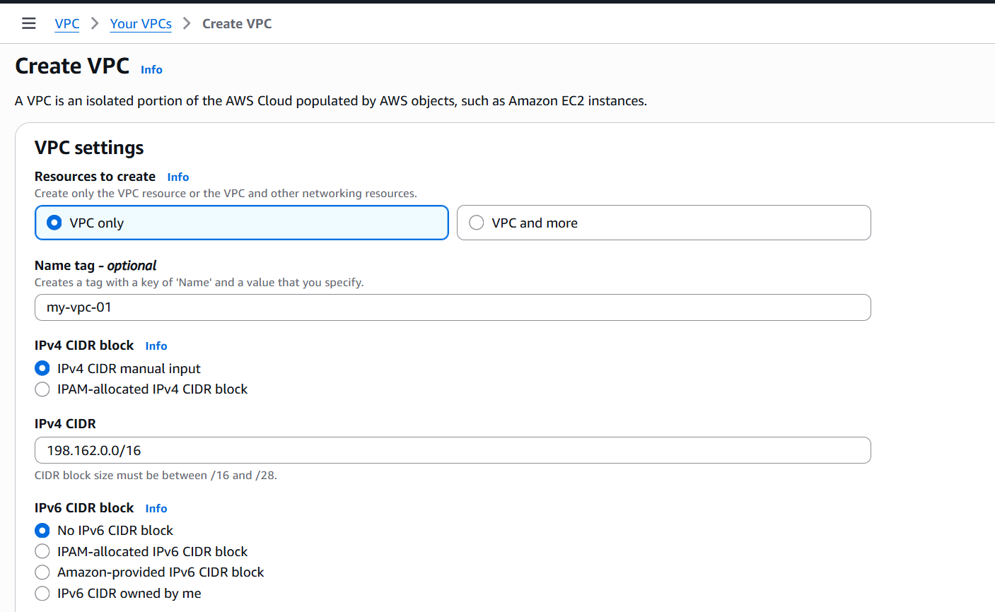
Step 4: Verify the details and click on create. VPC created.
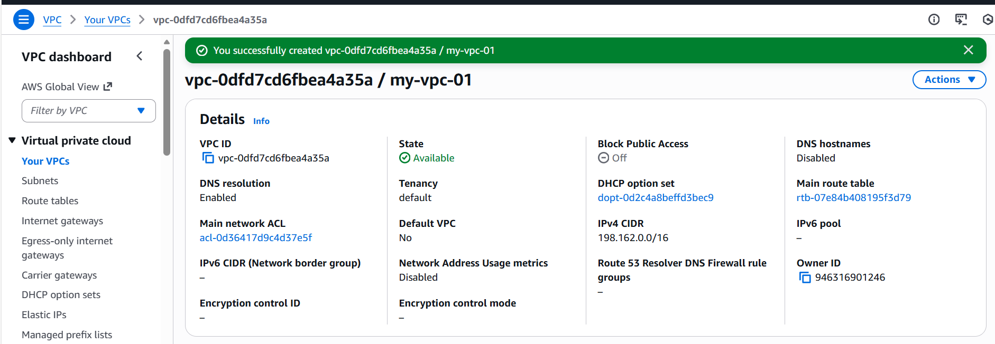
Validation Part:
We can verify the VPC created with CIDR range as we provided.
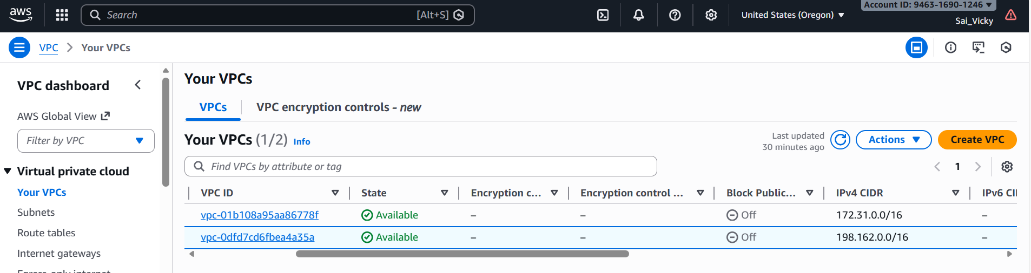

- Create two subnets: one public subnet and one private subnet.
Objective:
Subnets- Subnets are smaller portion of IP addresses. From the VPC CIDR created, we can allocate a certain portion of Ips through Public and Private subnets.
Prerequisites:
- VPC
- Subnets
Step by Step implementation:
Step 1: Scroll down next to VPC and select Subnets in the left column and click Create Subnet.
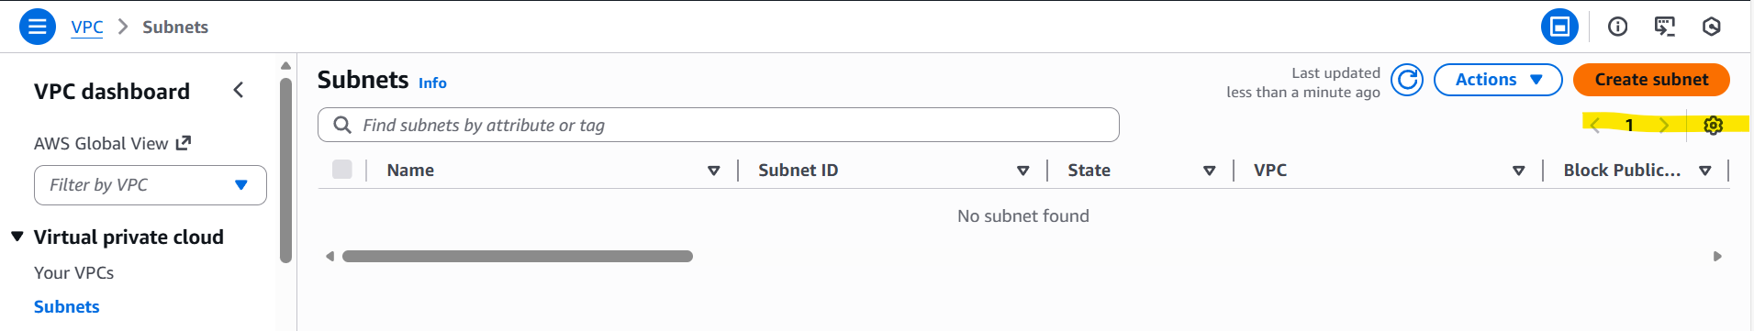
Step 2: Select the VPC which we want to connect.
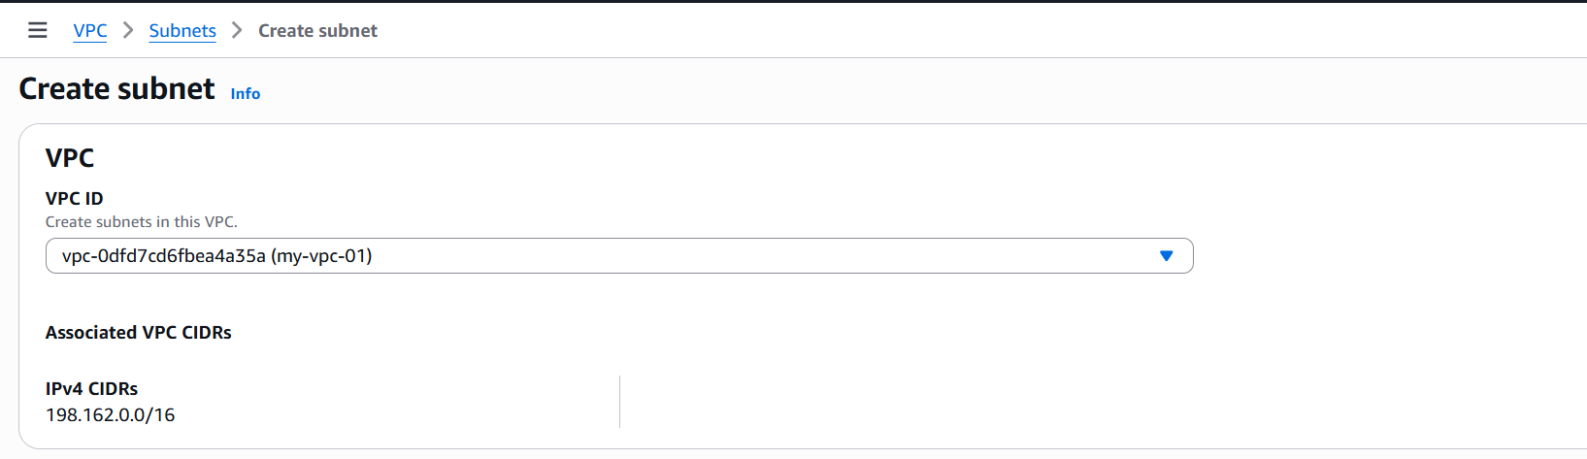
Step 3: Create a subnet name, in this case, I need 2 subnets, 1 for Public and 1 for private. Now, we are creating one public subnet below.
Availability zone- The zone is selected according to the region.
CIDR block- The CIDR block should not overlap with the VPC CIDR range, so we can get exact Ips that can be used as per subnet CIDR block.
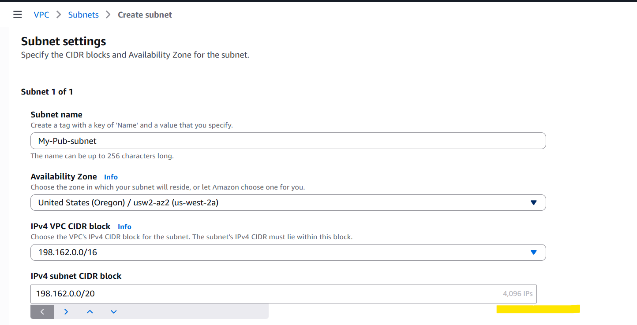
Step 4: 1 Public subnet created.
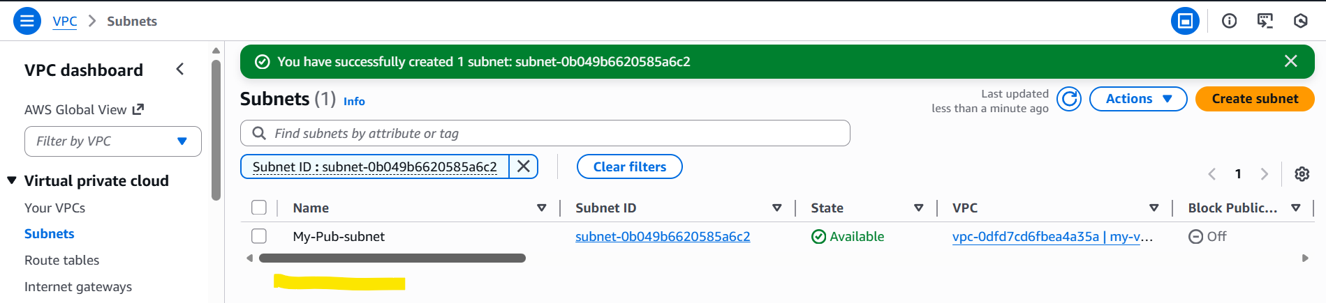
Step 5: Let’s create Private subnet as per the requirement. The CIDR block is a bit different to Public subnet, because there should not be overlapping.
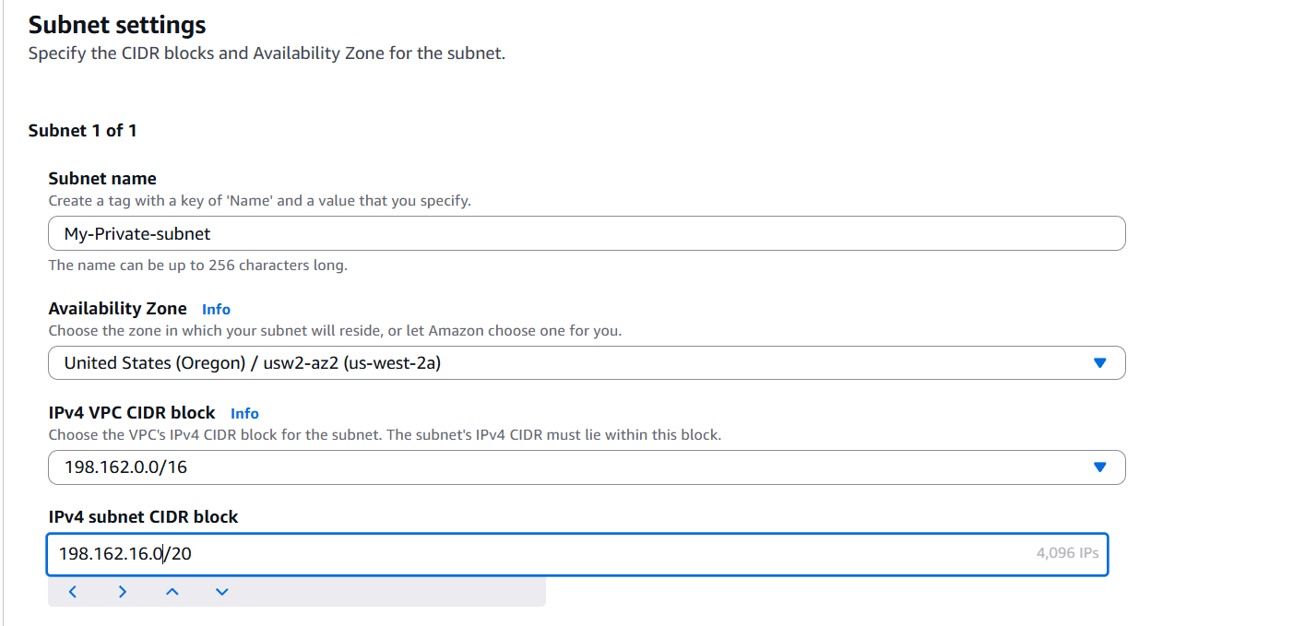
Step 6: We created 2 subnets and its not overlapping to the VPC created. As per the VPC CIDR, I can get 4096 Ips.
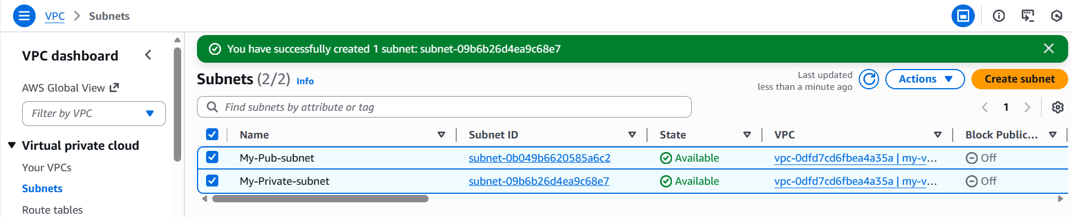

Validation:
- Always we need to make sure to provide correct CIDR blocks, so no 2 subnets will be overlapping with same VPC created.

- Attach an IGW to the VPC.
Objective:
Internet Gateway is shortform of IGW and this is used to provide internet access to the subnets and specially to the Public subnets only.
Prerequisites:
- VPC
- Subnets

Step by step Implementation:

Step 1: We need to create a IGW to connect with our VPC.
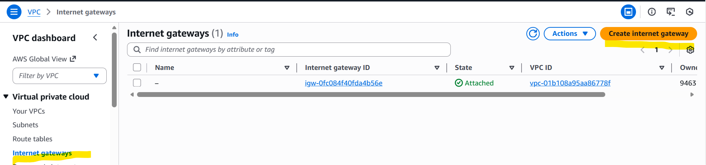
Step 2: Provided name for my IGW and hit Create Internet gateway.
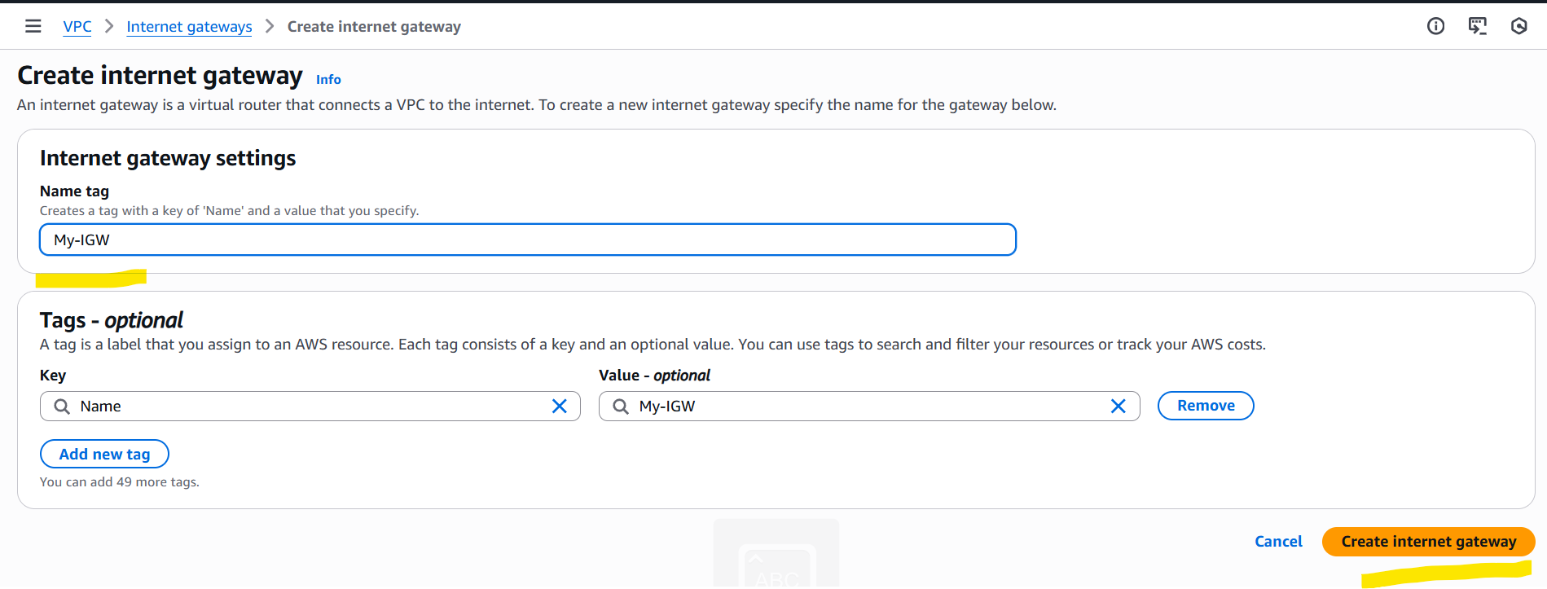
Step 3: Now my IGW is created.
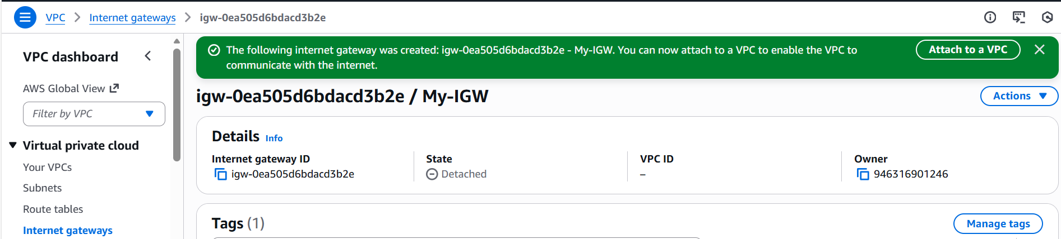
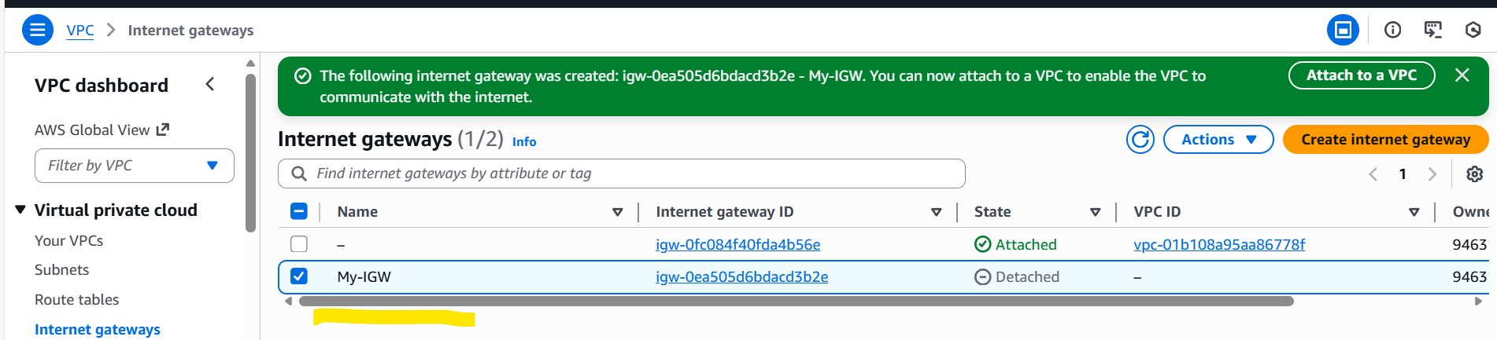
Step 4: Now we need to attach the IGW to my VPC.
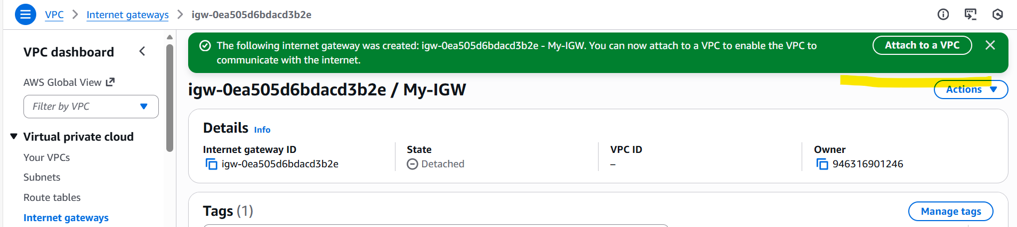
Step 5: Selected my VPC to attach.
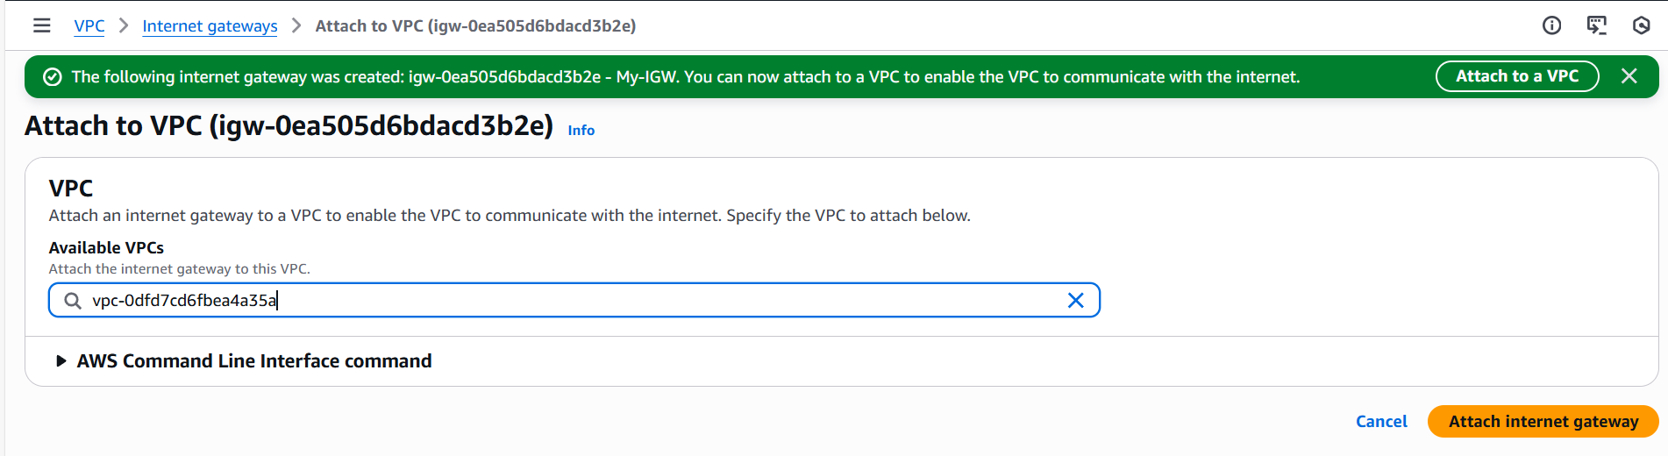
Step 6: Now, we can see our VPC attached to the IGW.
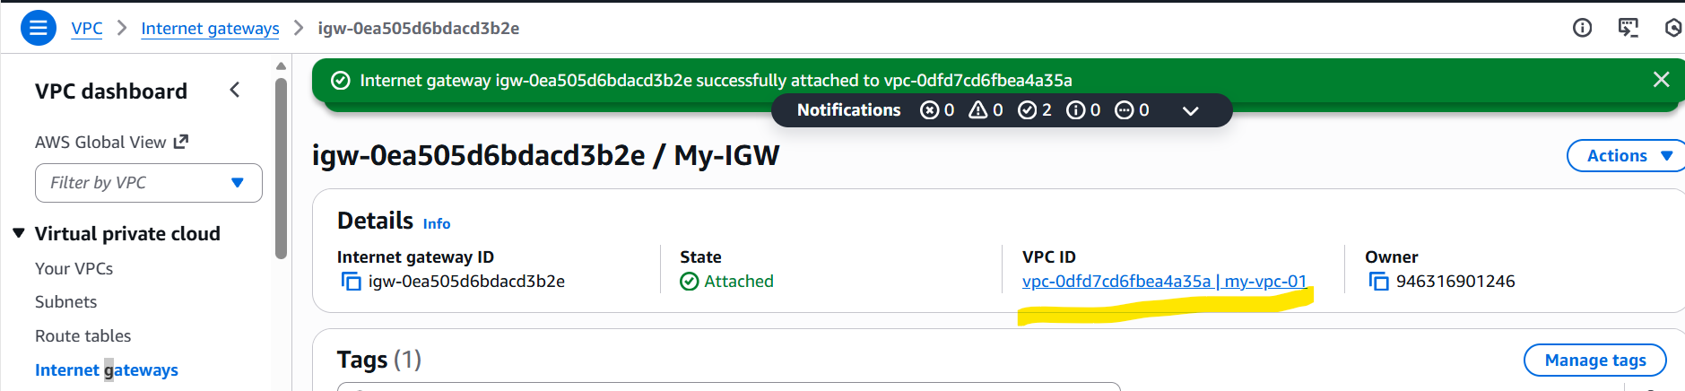
Validation: The steps are validated and now we can communicate with our VPC via IGW.

- Create one public route table (RT) and one private route table.

Objective:
We need to create one public and private route table to control traffic flow and map the destinations like internet gateway to ensure secure and organized network.
Prerequisites:
- VPC
- Subnets

Step by step Implementation:

Step 1: Create a route table to get started.

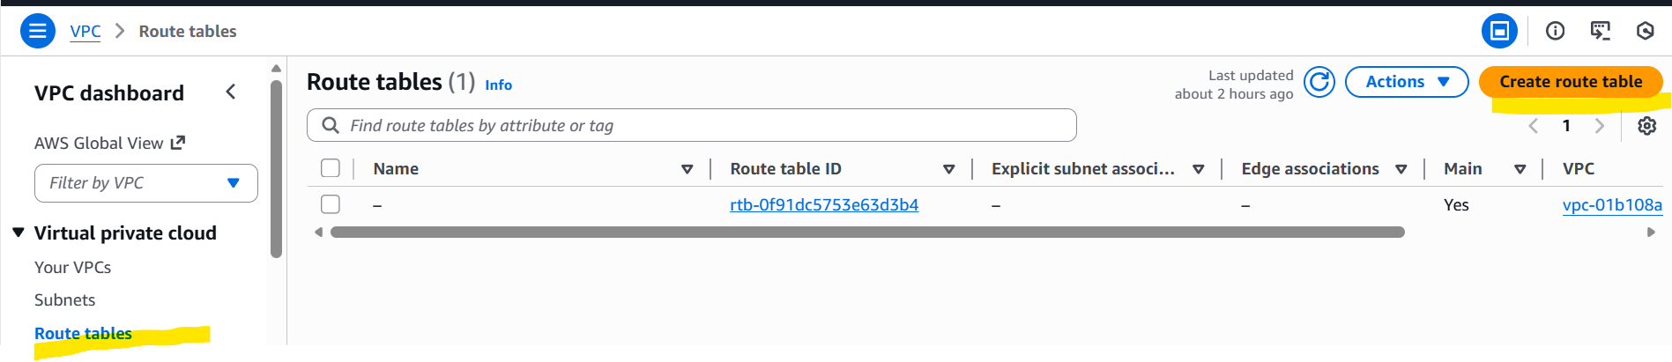
Step 2: Name the route table as per the requirement. Below is my public route table.
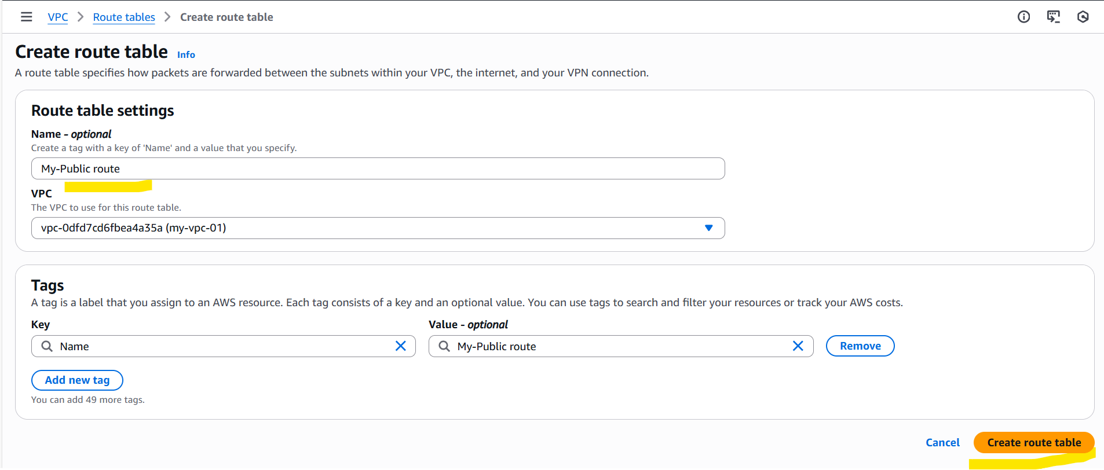

Step 3: Now my public route is created successfully.
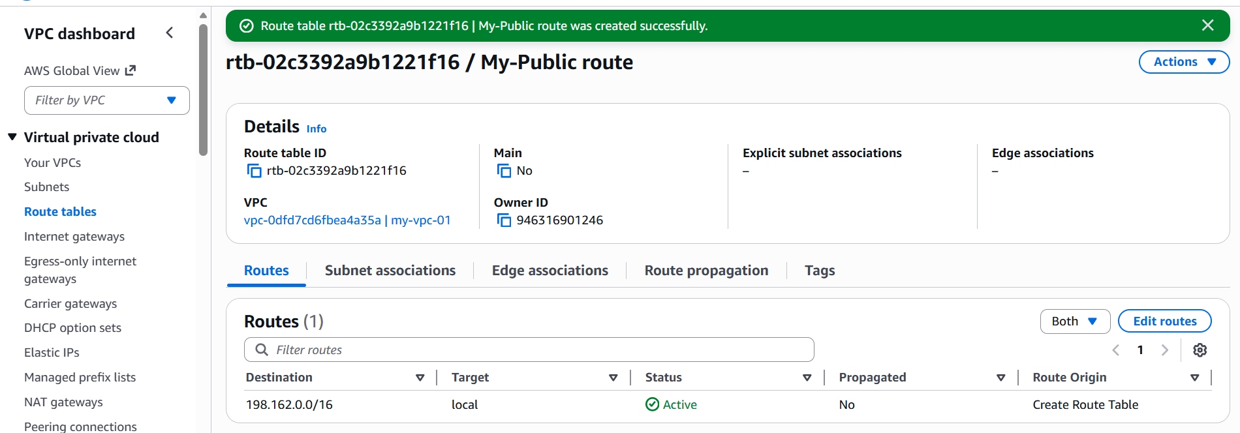

Step 4: Now we need to got to the Edit subnet associations and select the subnet to map the destination.
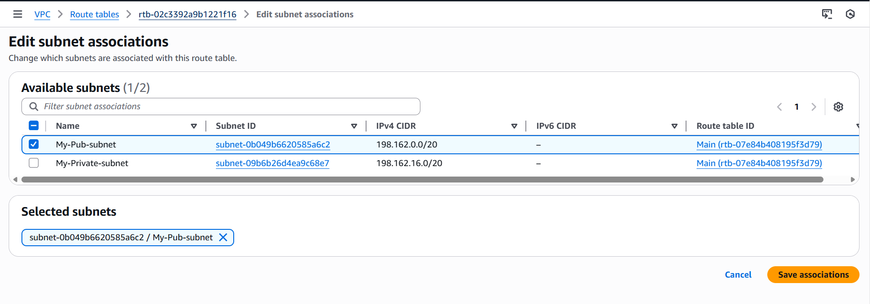

Step 5: Now, lets create a private route as our next step.
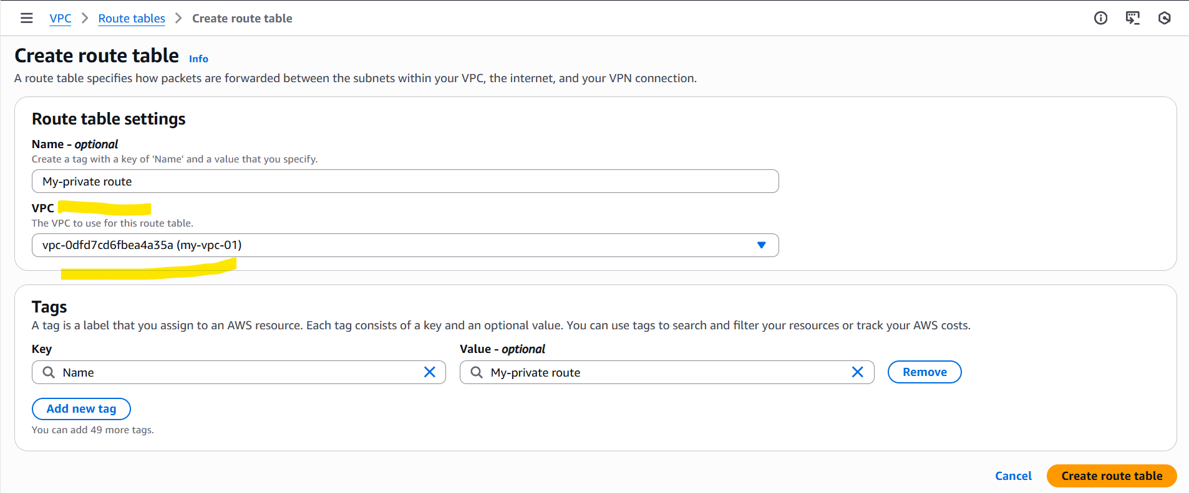

Step 6: Once the route created, Edit subnet association is updated with private subnet.
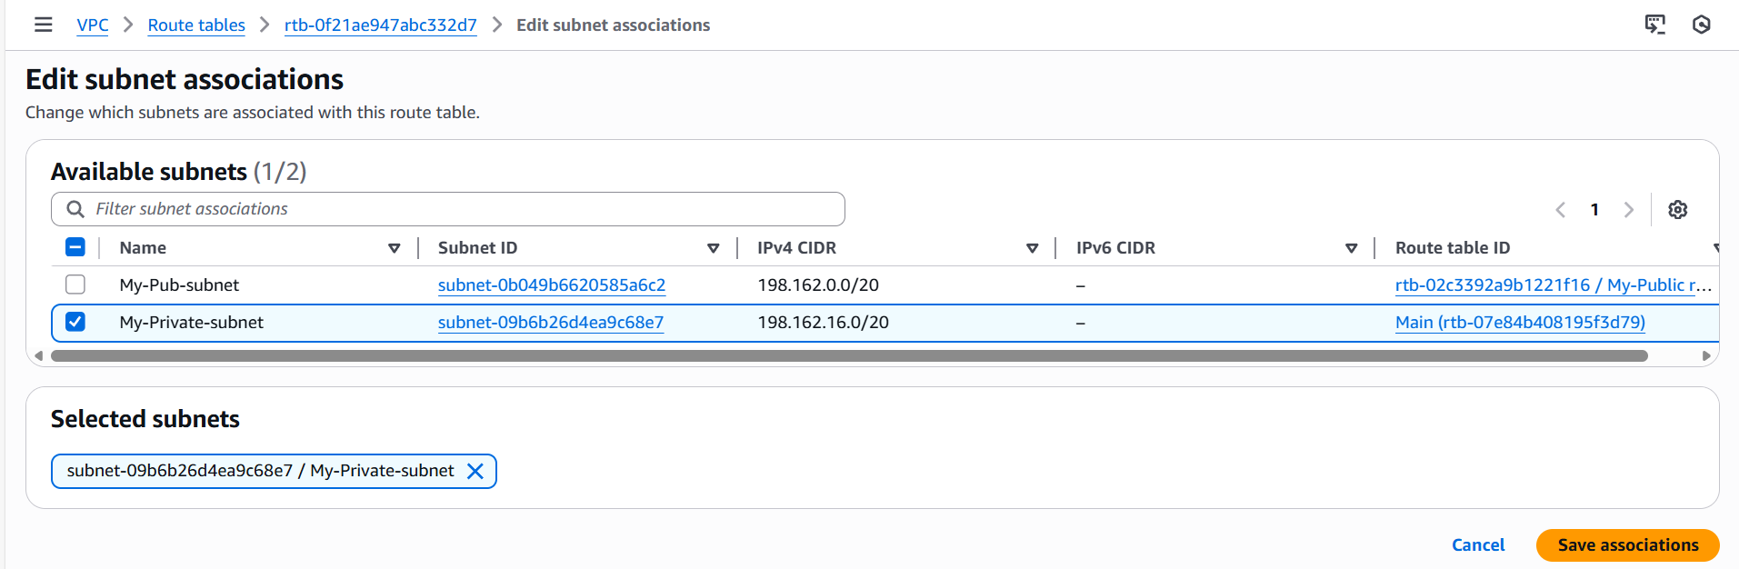

Step 7: Now the Public route and Private route is updated with our VPC.
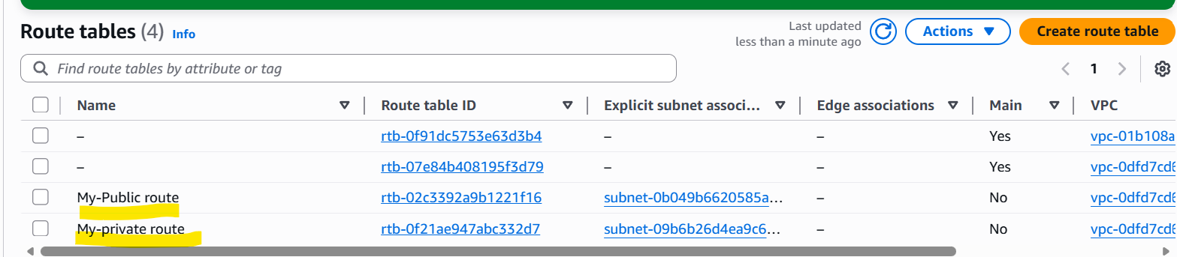

Note: Public route and Private route is very important to control traffic and map the destinations.

- Deploy a NAT gateway in the public subnet and attach the NAT gateway to the private subnet.

Objective:
The objective of NAT gateway is to enable the internet access outbound to private instance from deploying NAT gateway in public subnet and routing private subnet traffic through it.
Prerequisites:
- VPC
- Subnet
- Route Tables
- Internet Gateway
- Elastic IP
Step by step Implementation:
Step 1: Navigate to VPC and scroll down to left and select NAT gateway and click Create NAT gateway.
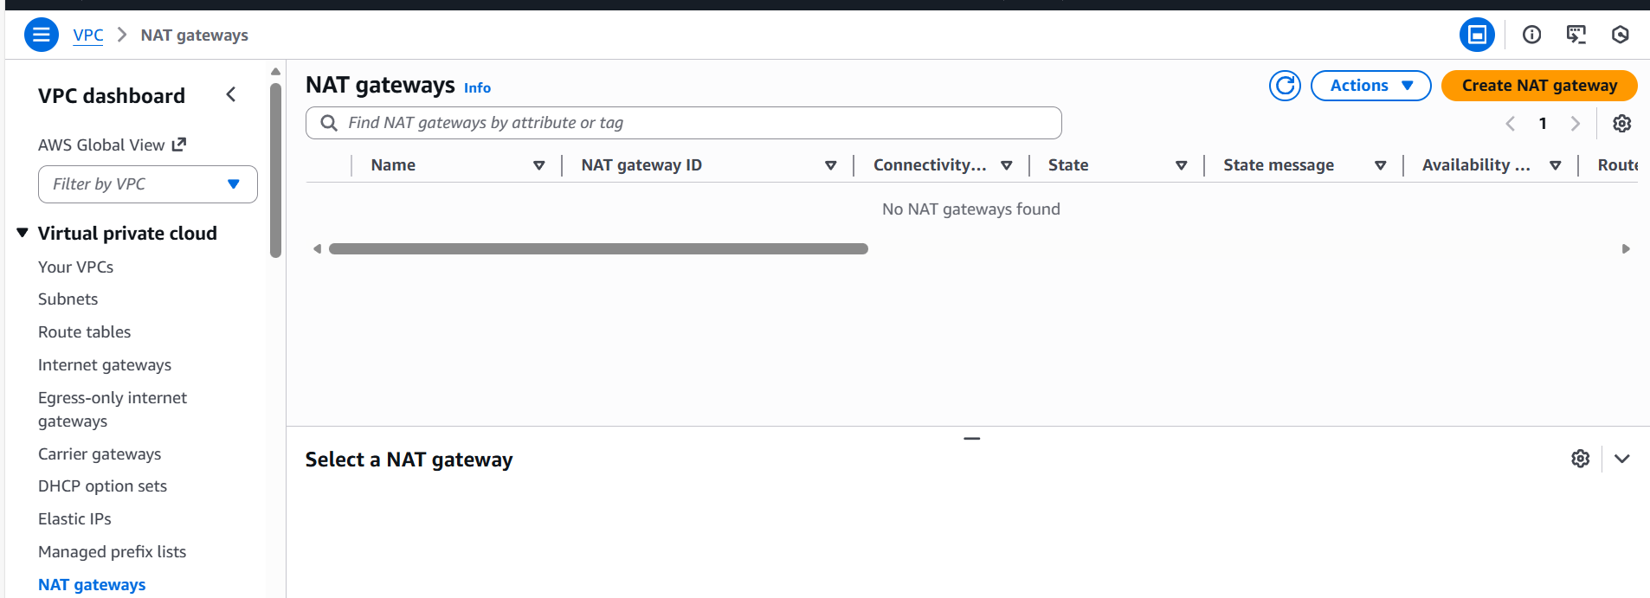

Step 2: Name the NAT gateway and Availability mode should be Zonal if we need to connect with Private instance.
Attach the public subnet created earlier.
Connectivity type should be Public as well.
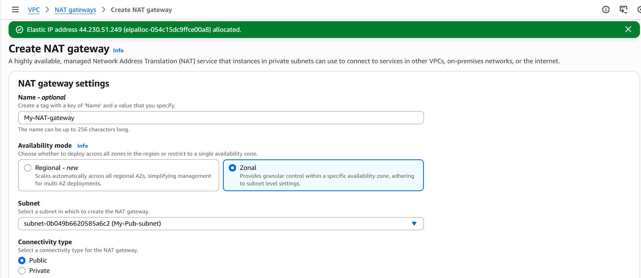

Step 3: One Elastic Ip has been allocated, so that our IP will be fixed and it will not be removed from our VPC.
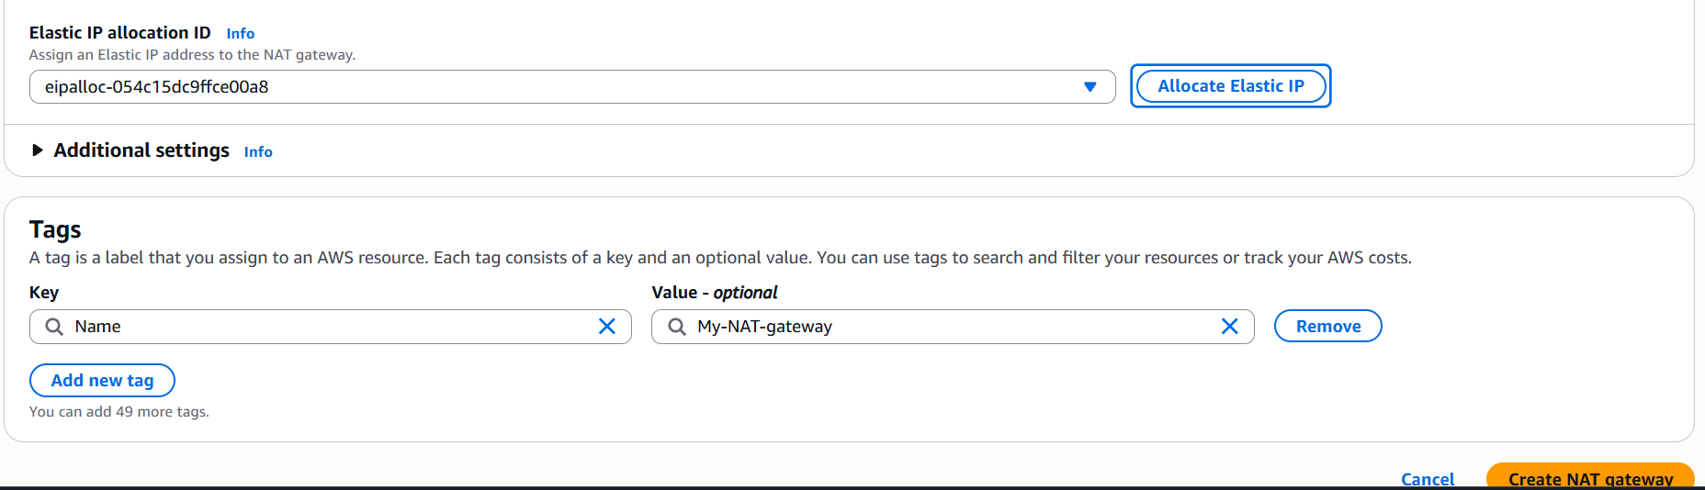

Step 4: Nat gateway created successfully.
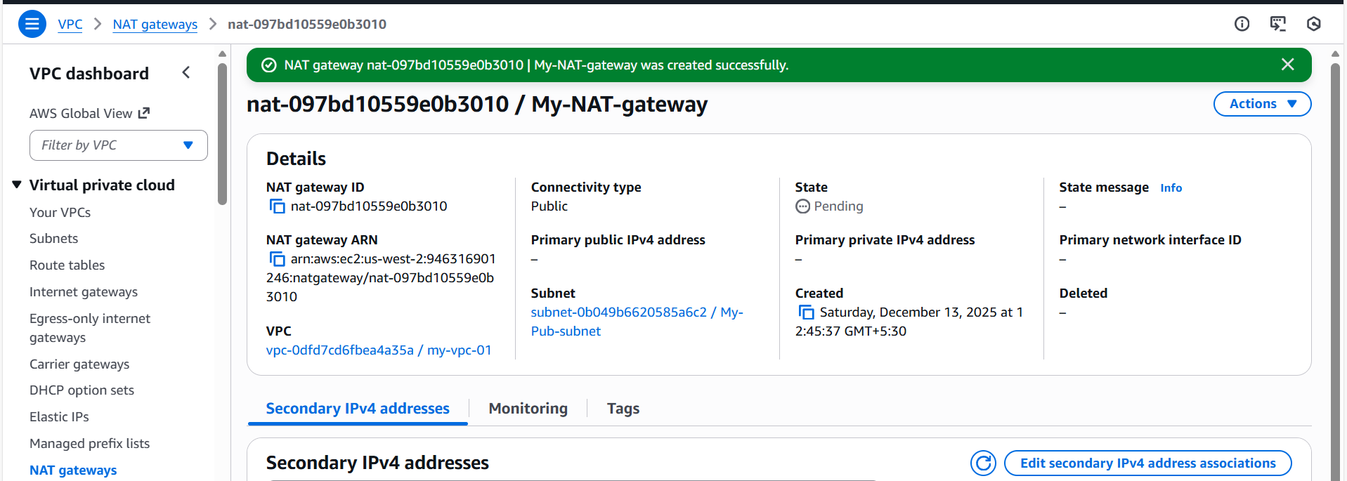

Step 5: Now its time to route the NAT gateway to Private route, so that internet outbound will get started.
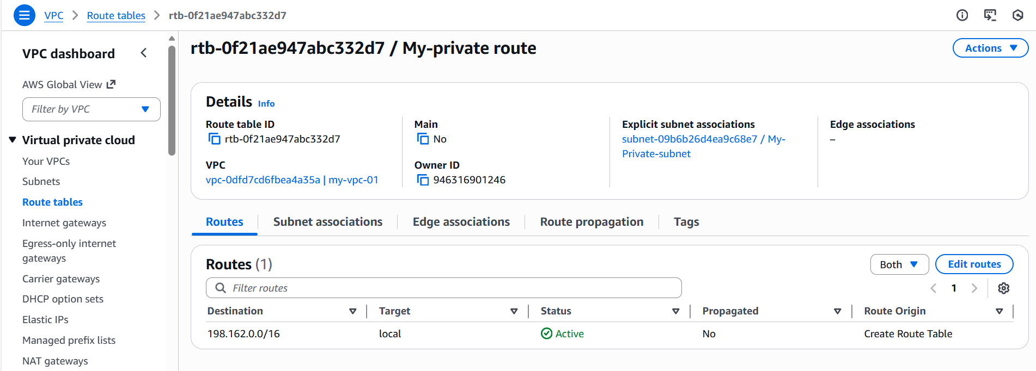

Step 6: Edited route in private route with NAT attached.
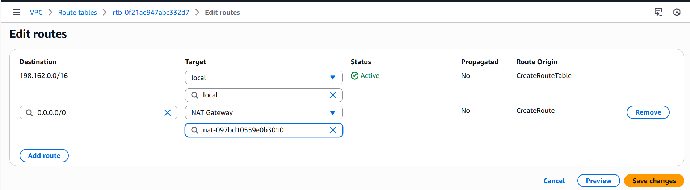

Step 7: NAT attached successfully.
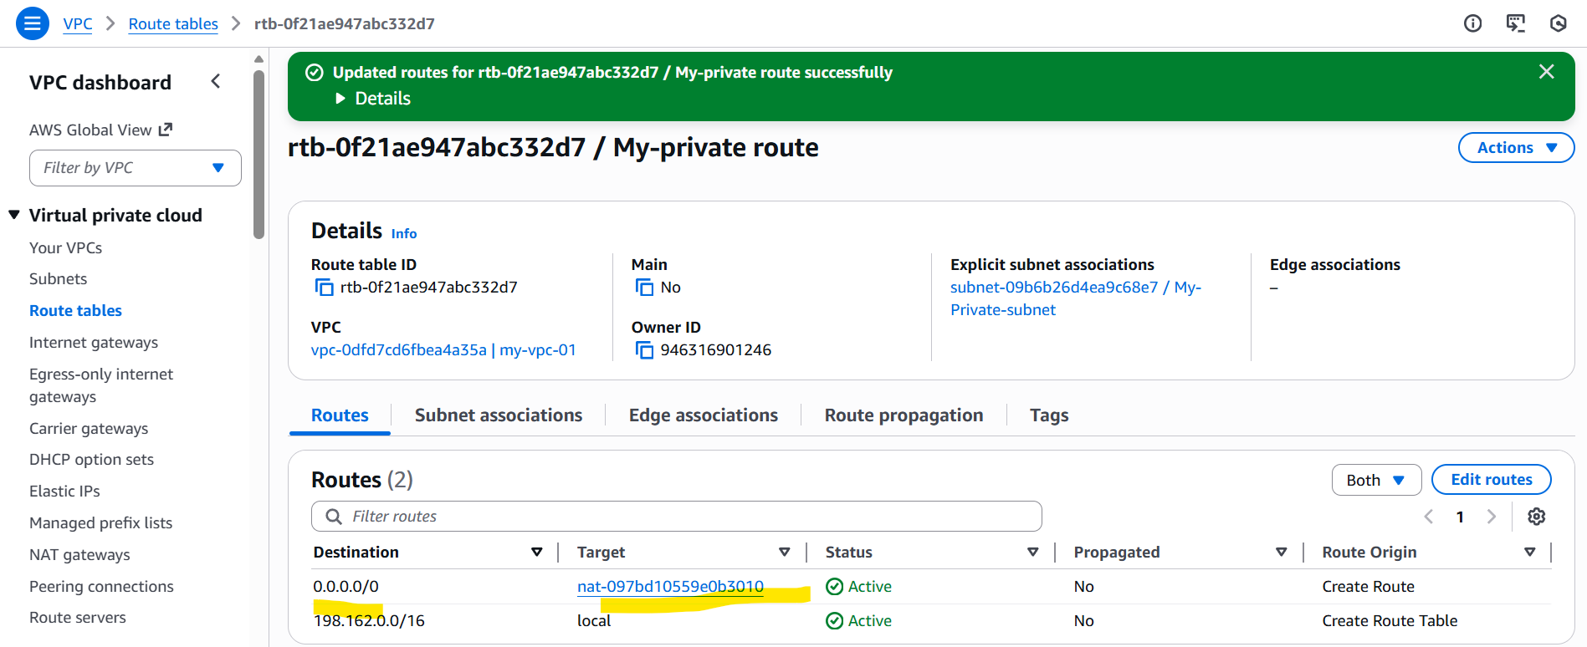

Step 8: Save the subnet associations, so that internet connectivity will work when pinging with private instance.
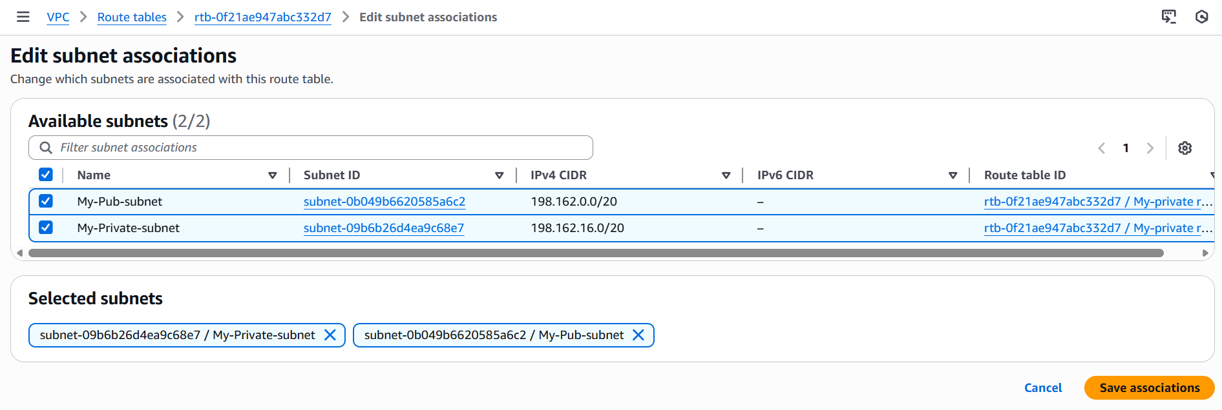

Step 9: Let’s connect Internet gateway to public route, so we can connect with private instance immediately.
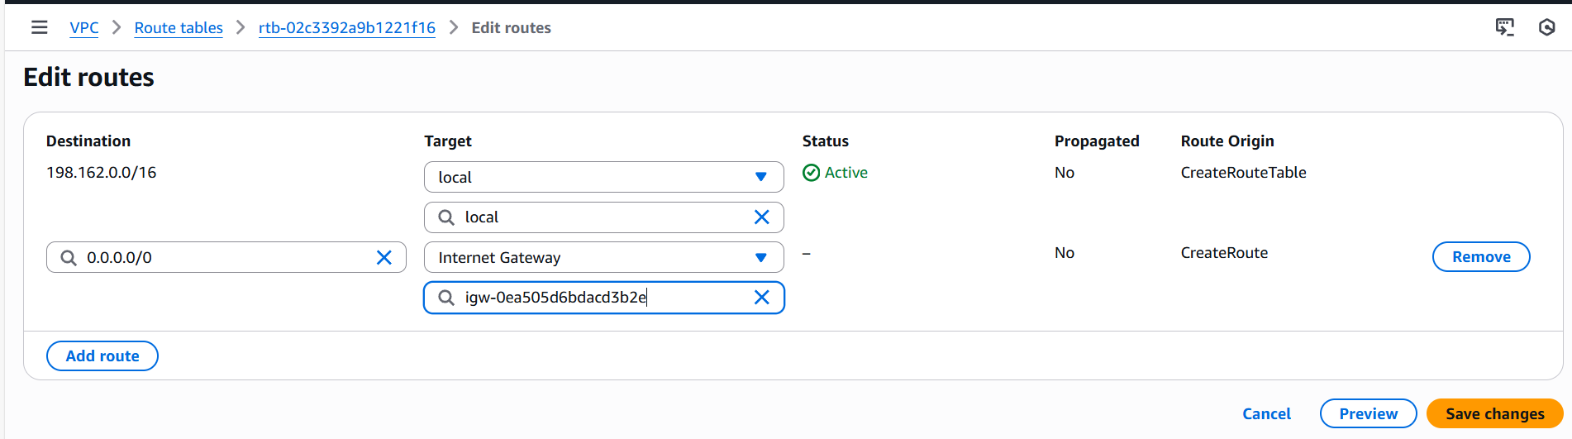

Note: A reminder to save the subnet associations, as I have always missed that step to save, without saving, we cannot connect to private instance internet outbound.

- Create two instances, one in the public subnet and one in the private subnet.
Objective:
Creating two instance to connect with public subnet and private subnet, where public subnet will have internet access and private will not have internet access.

Prerequisites:
- AWS console
- VPC
- Subnets
- IGW
Step by step Implementation:
Step 1: Launching 1st instance with public subnet.
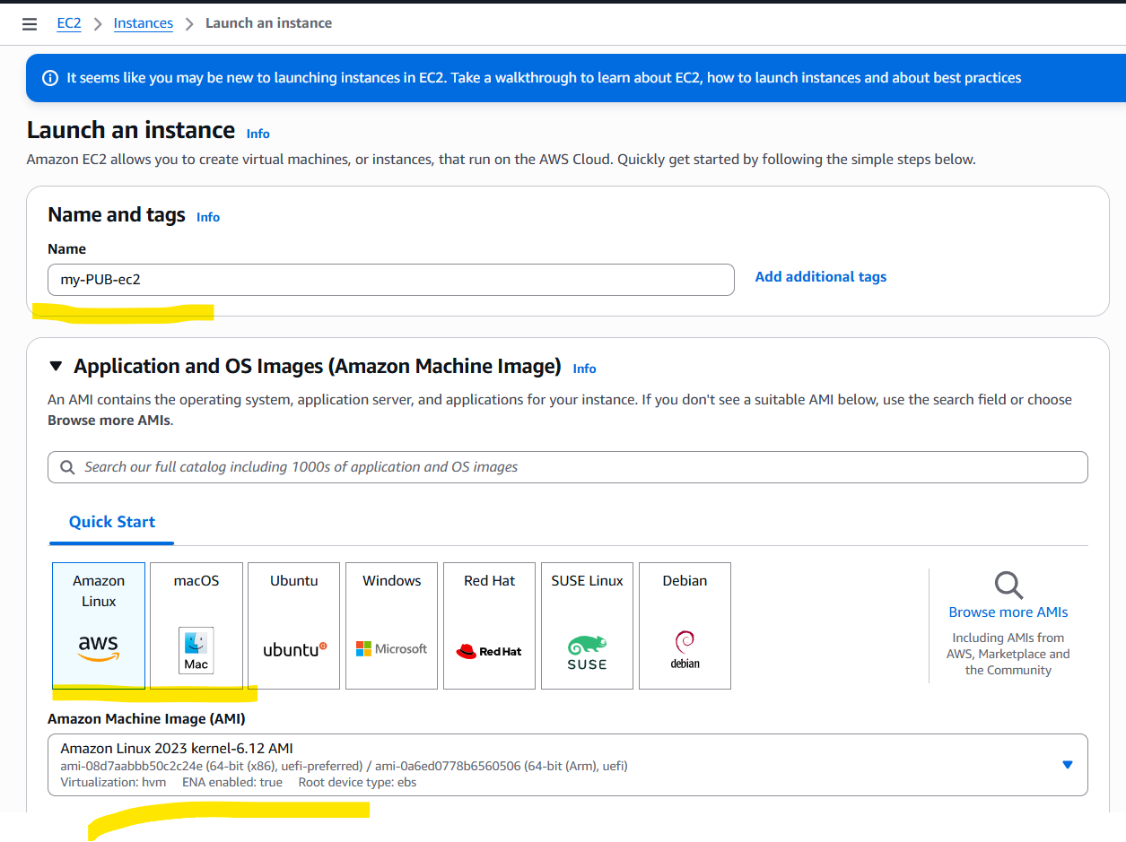

Step 2: As per the requirement, attached VPC and public subnet created earlier.
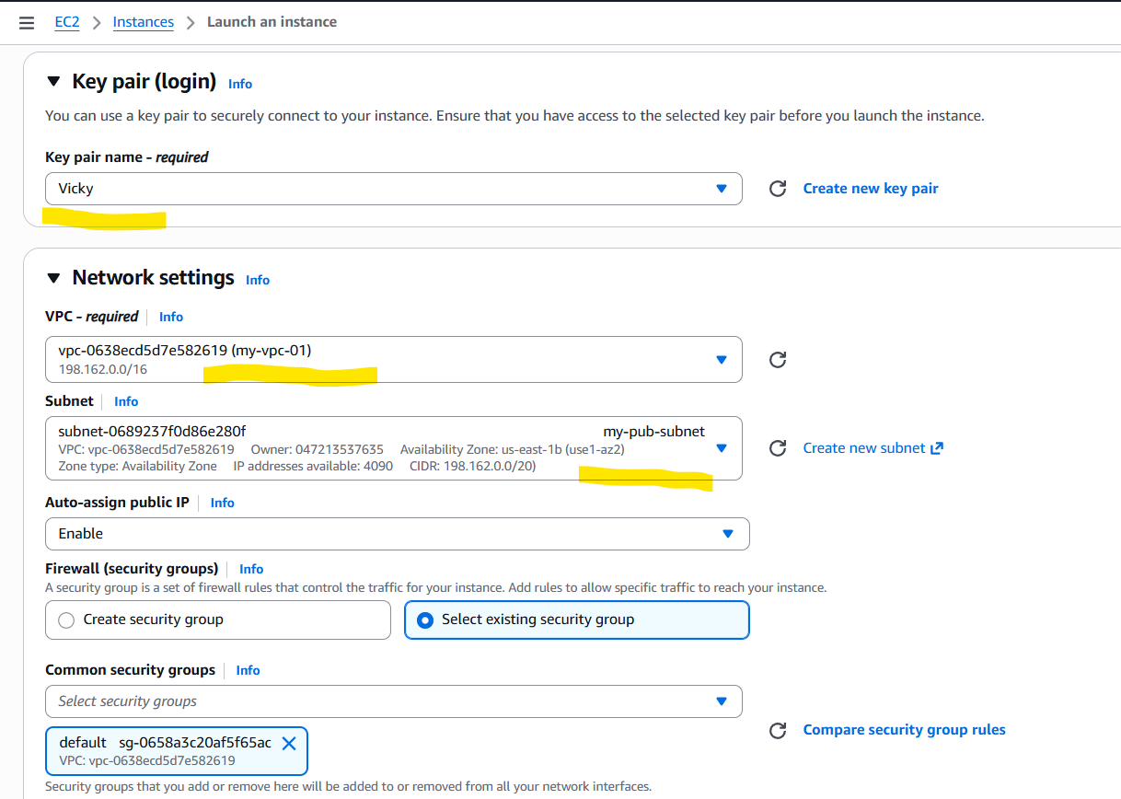

Step 3: Instance launched successfully with public subnet.
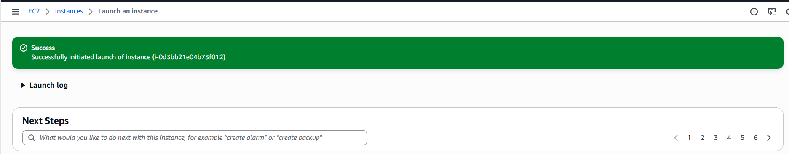

Step 4: Launching our second instance with private subnet.
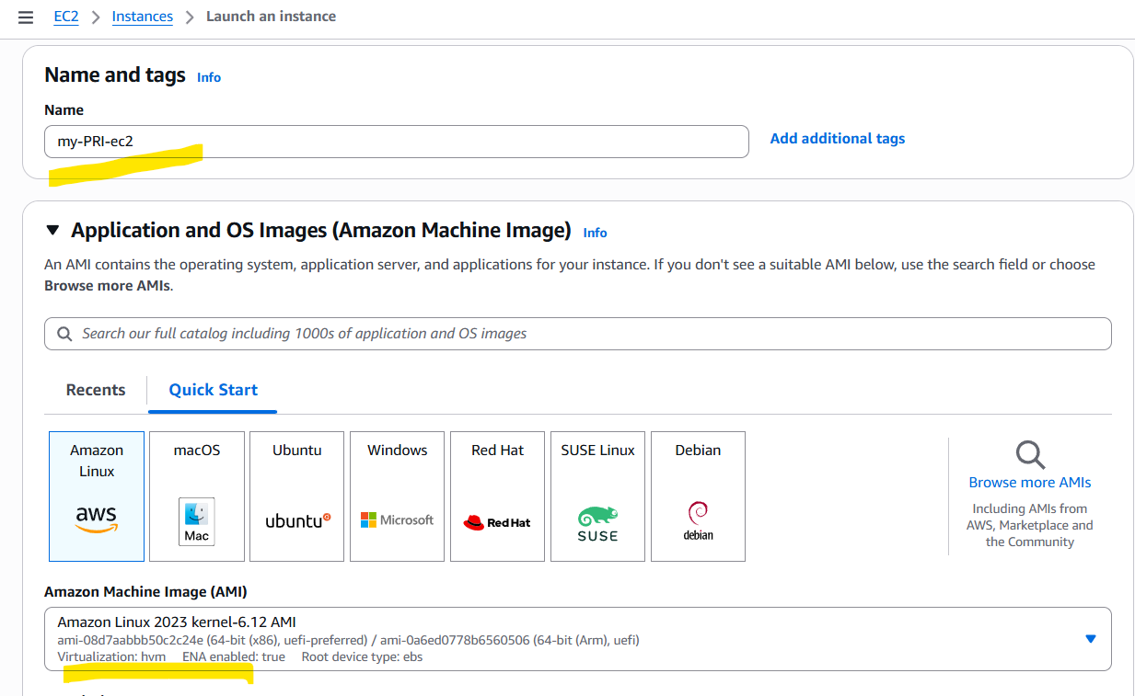

Step 5: Attached private subnet which doesn’t has internet gateway.
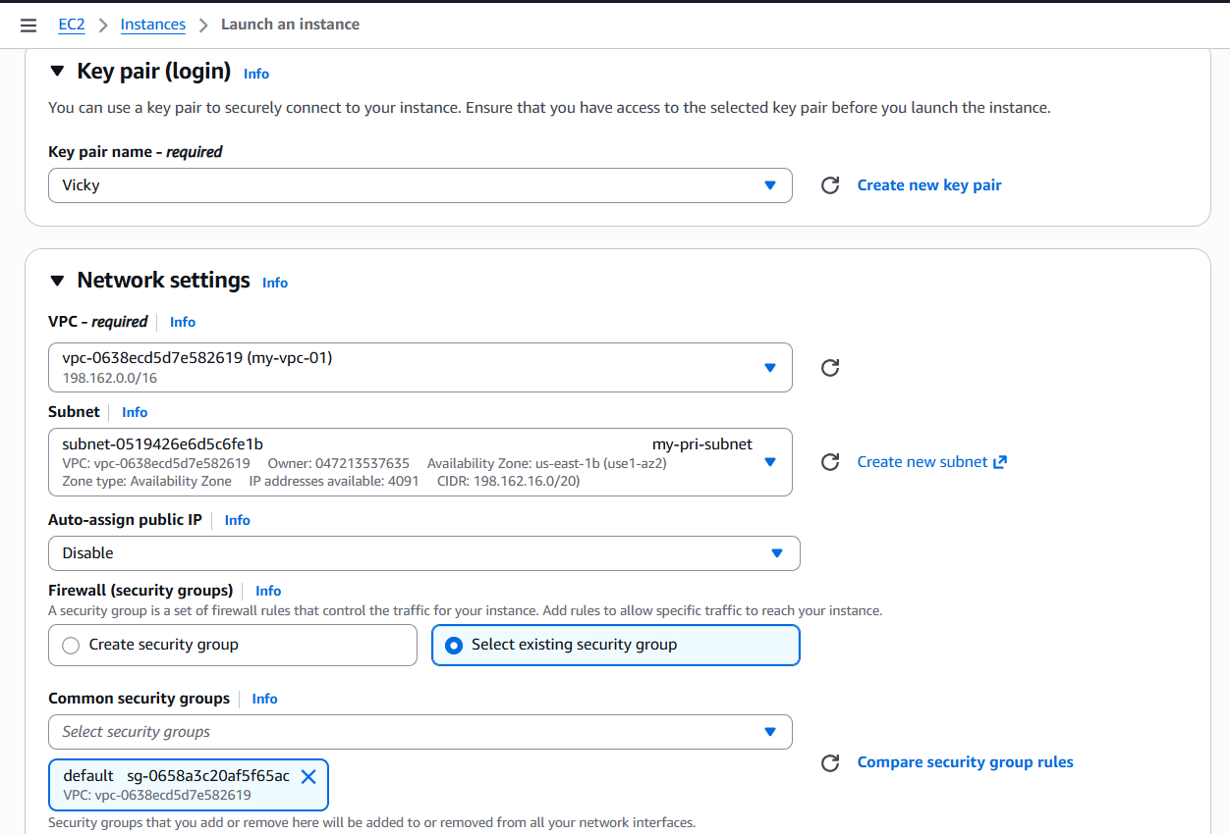

Step 6: Instance launched successfully with private subnet.
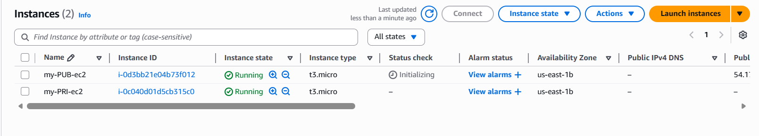

- Note: When creating ec2, to make sure to attach the subnets properly, because that way, our subnets will work correctly.

- Deploy Apache server on both EC2 instances with a sample index.html file.

Objective: To deploy Apache server between Public and Private ec2 and connect them.

Prerequisites:
- Ec2
- VPC
- Subnets
- Security Groups
- Apache package
- .pem keypair

Step by step Implementation:
Step 1: Launching 1st instance with public subnet.


Step 2: As per the requirement, attached VPC and public subnet created earlier.


Step 3: Instance launched successfully with public subnet.


Step 4: Launching our second instance with private subnet.


Step 5: Attached private subnet which doesn’t has internet gateway.


Step 6: Instance launched successfully with private subnet.


Step 7: Let’s get connected with public ec2 to install HTTPD package.
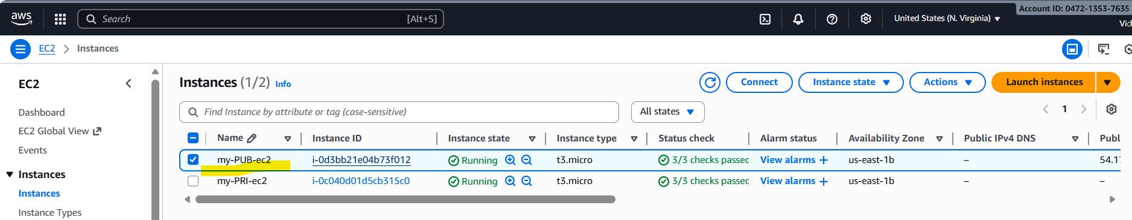
- Copied the ssh and connecting from git application.
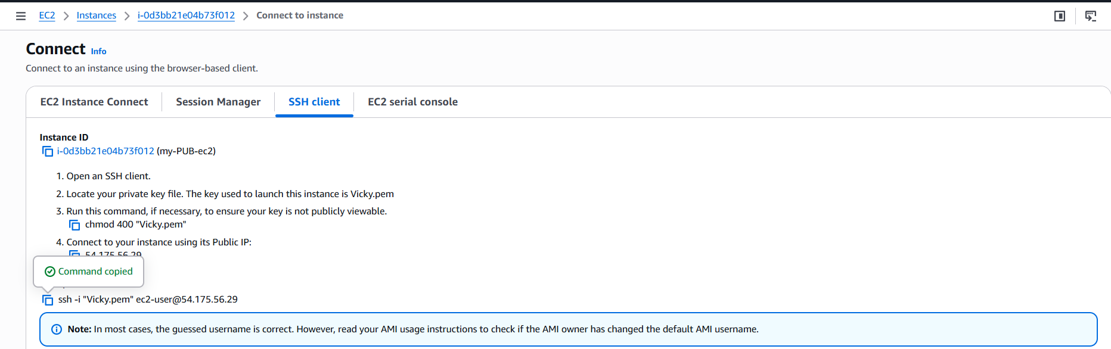
- The connection failed due to existing security groups didn’t had ssh route to get connected.
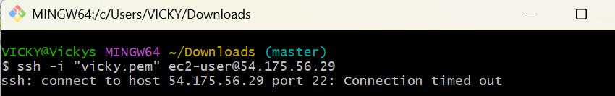
- Success. We were able to get connected to the public subnet with ec2 (CLI)
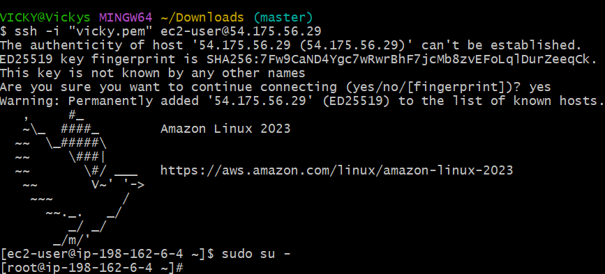

Step 8: Install Apache package (httpd)- yum install httpd -y
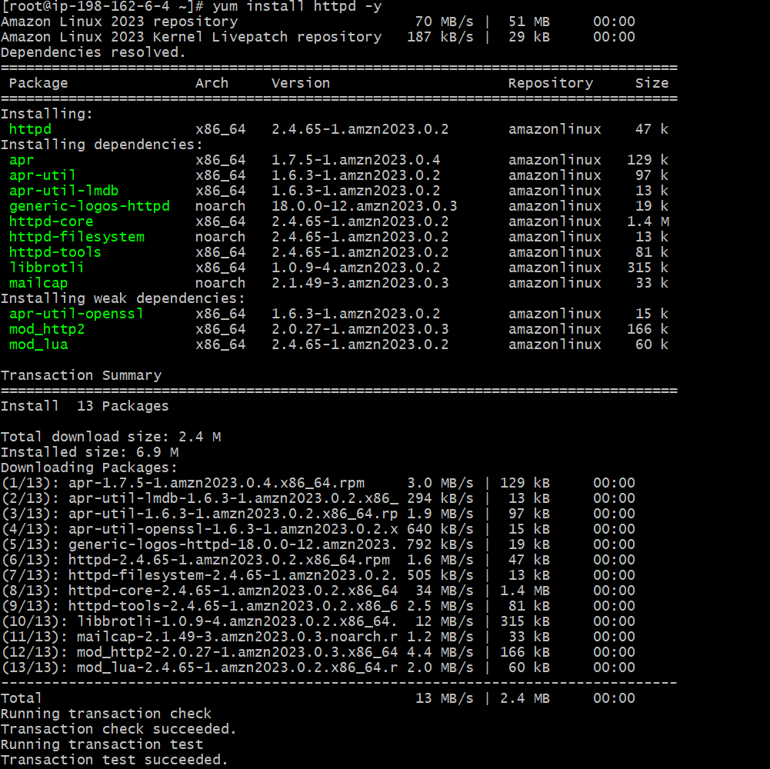
- Verify the status and start the package.
- Success- the package has started successfully and active status.
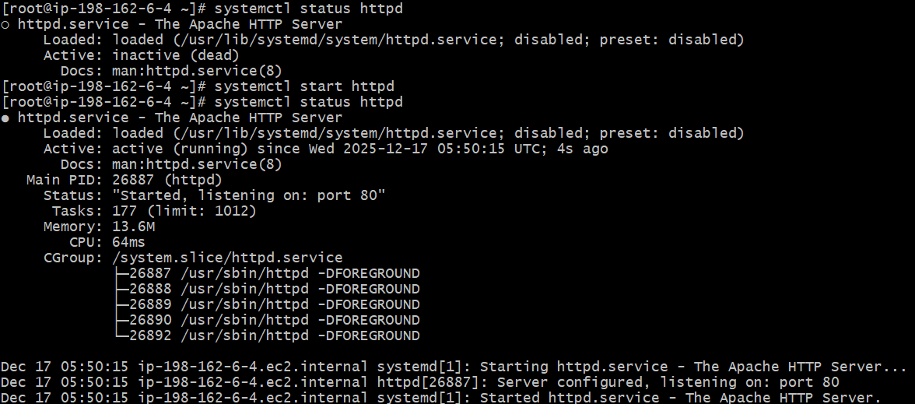

- Now, it’s time to verify on the browser as well with Public ip.


Step 9: Now, we need to create a index.html file and insert the below data to test if Apache server is working.
Change the directory to /var/www/html
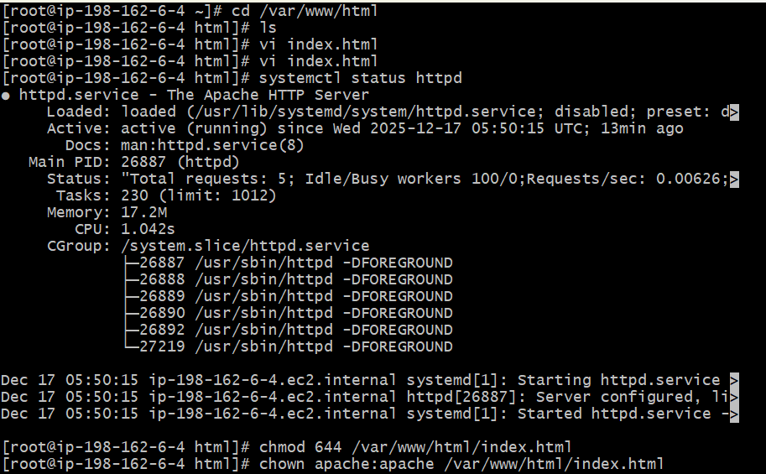

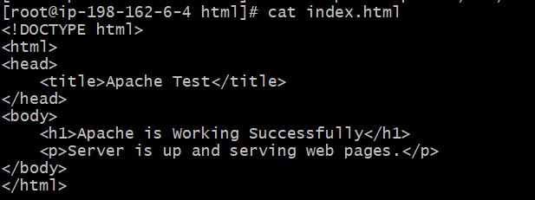
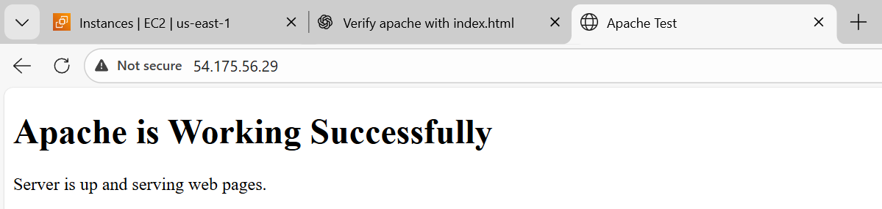

Step 10: Let’s try connecting with second ec2 private IP to connect with Apache server. Of course it will not work, because there is no internet.
- We shall use bastion/jump server option to connect with private instance. But the catch here is, we have attached NAT gateway to the private route, so we will get internet connection.

Copy the ssh CAT pem.key from the pem.key location in local folder.
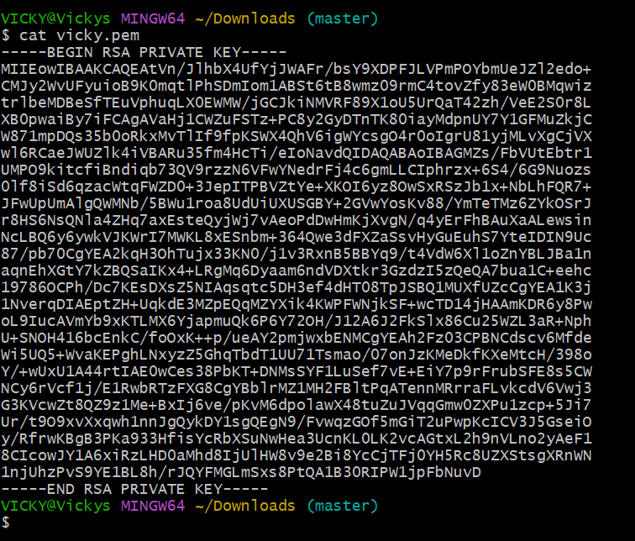

- Created a pem using vi test.pem and provided permissions using chmod 600 test.pem.

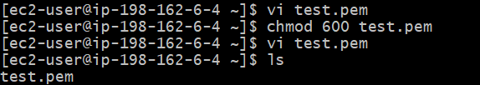

- Now, let’s connect with second ec2 private ip and verify if the connection is successful
- Let’s ping internet as well to verify if the NAT is providing outbound access.

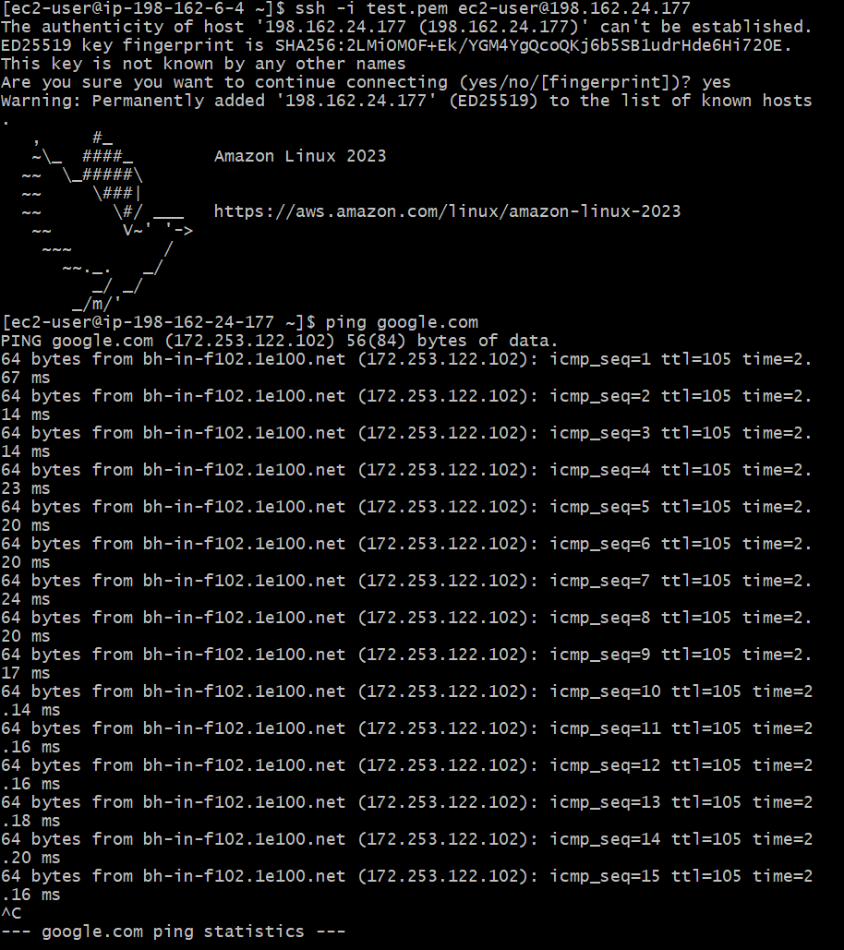

Step 11: Now let’s install Apache server in private ec2 as well.

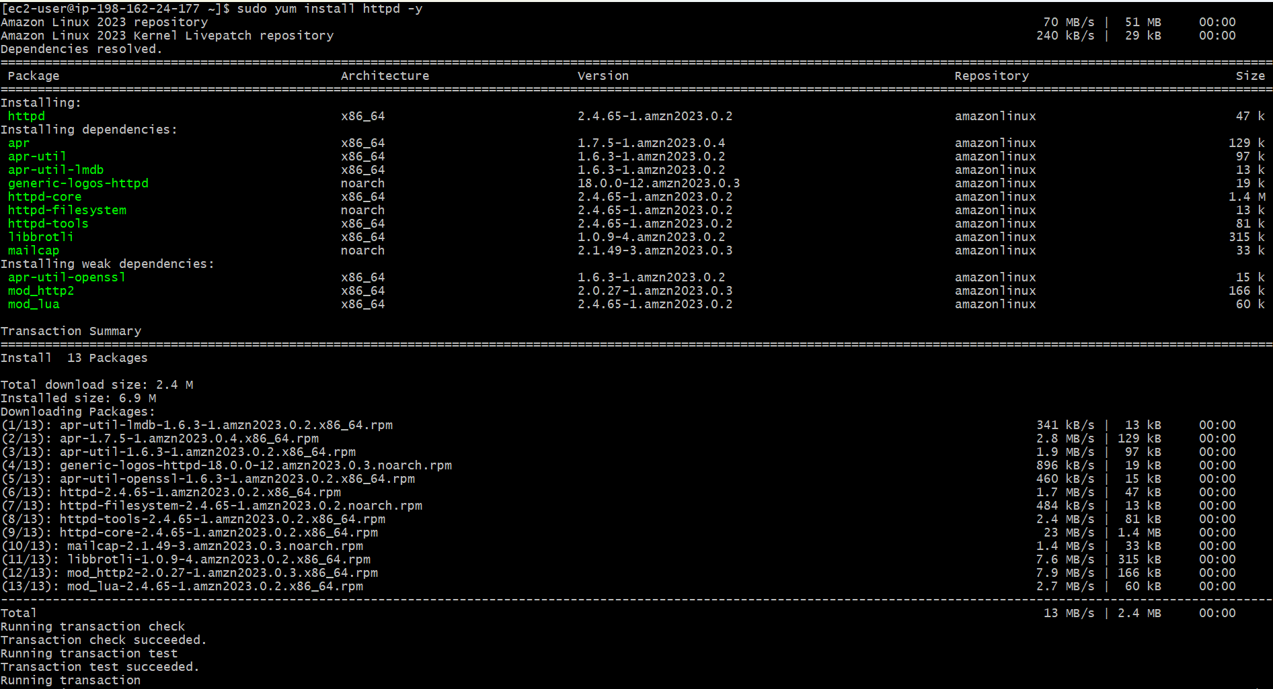
- Verified the status and start using command- systemctl start and status httpd.
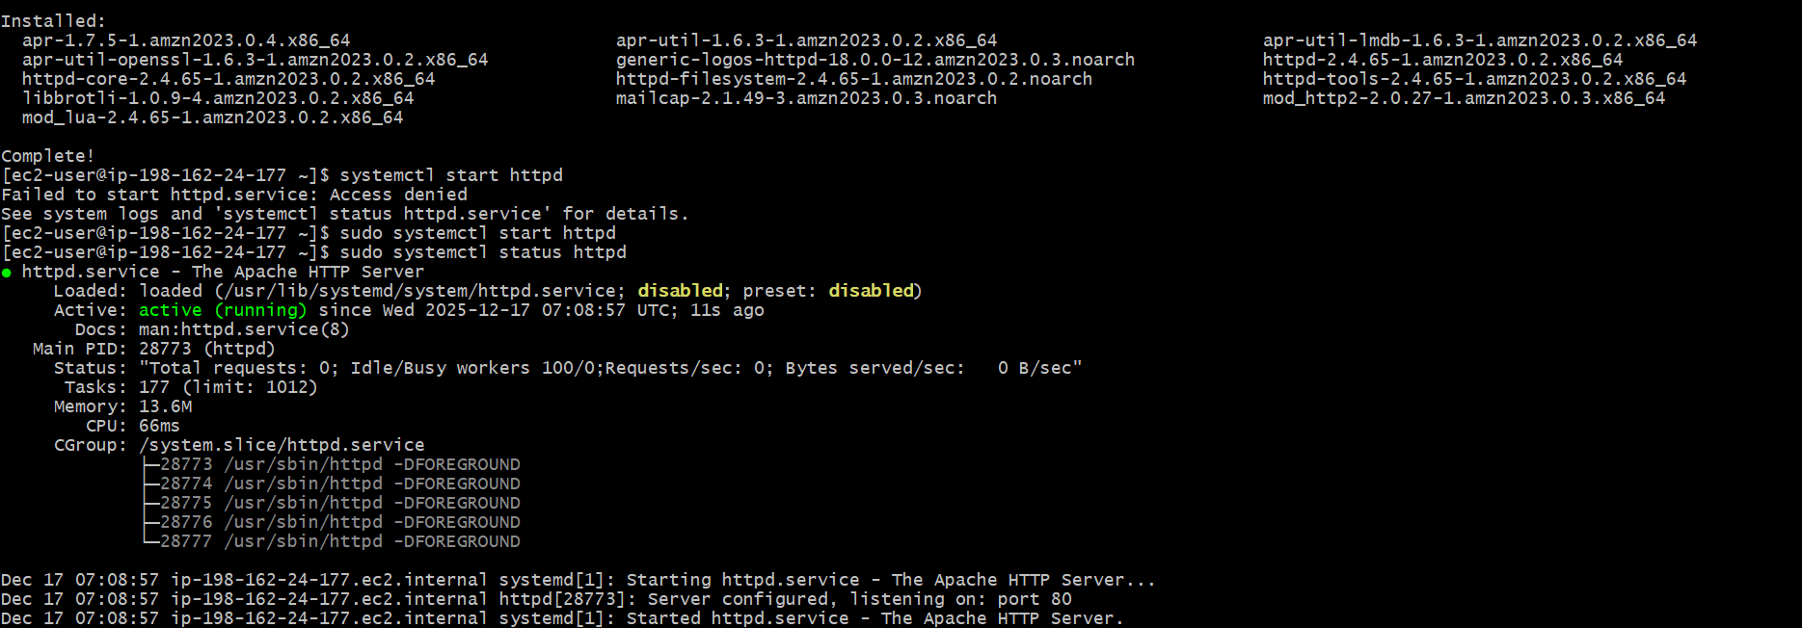
- Now, let’s change the directory and create a index.html.
- Provide permissions- chmod 644 index.html
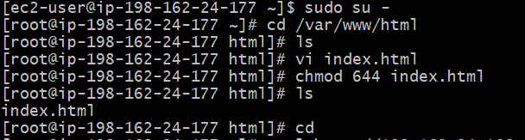

- Verified in CLI if Apache is working using command- curl http://198.162.24.177:80. Success.
Note: The issue faced above was when connecting with private ec2, its recommended that, always use the pem.key when connecting between 2 ec2’s.

Conclusion: Apache is deployed in both ec2 instances and the index.html is served as exactly as the web servers are functioning as correct with subnets.

- Create one application load balancer and attach it to both EC2 instances.
Objective:
The objective of this task is to deploy an Application Load Balancer and attach both ec2 instances to control traffic and ensure high availability of the web application.
Prerequisites:
- VPC
- Subnets
- Ec2
- Load Balancer
- Target Groups
- Apache package
- Index.html
Step by step Implementation:
Step 1: Create a new subnet in a different zone and with the same CIDR range which our VPC is attached.
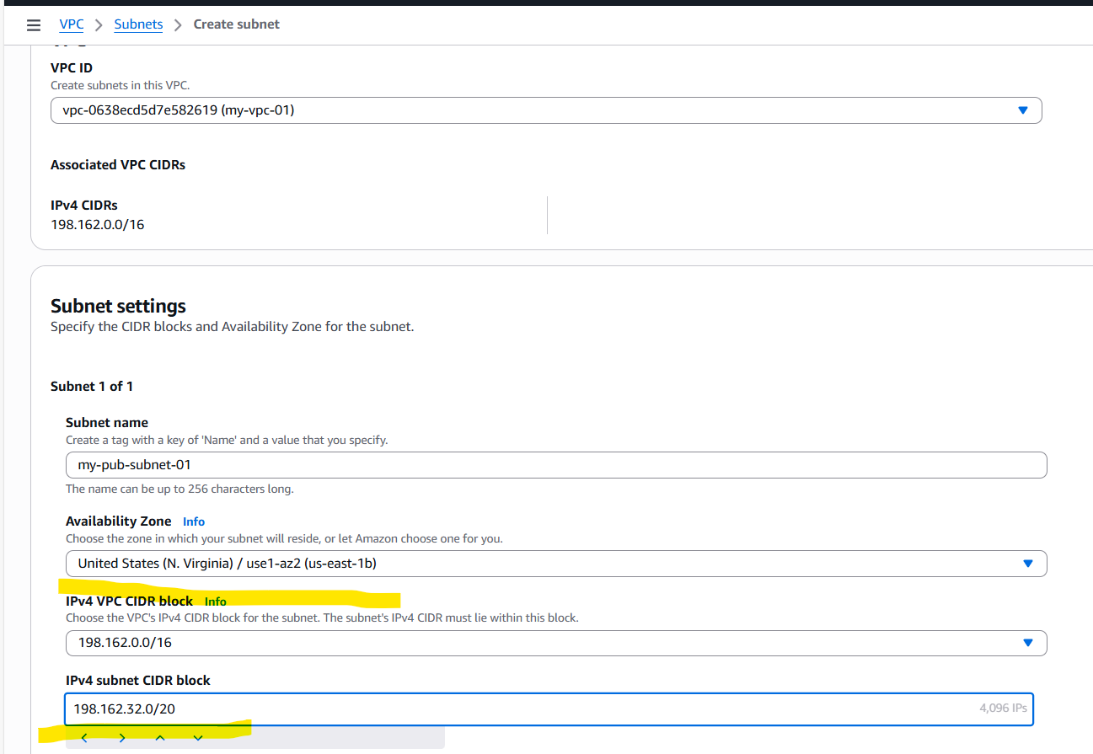
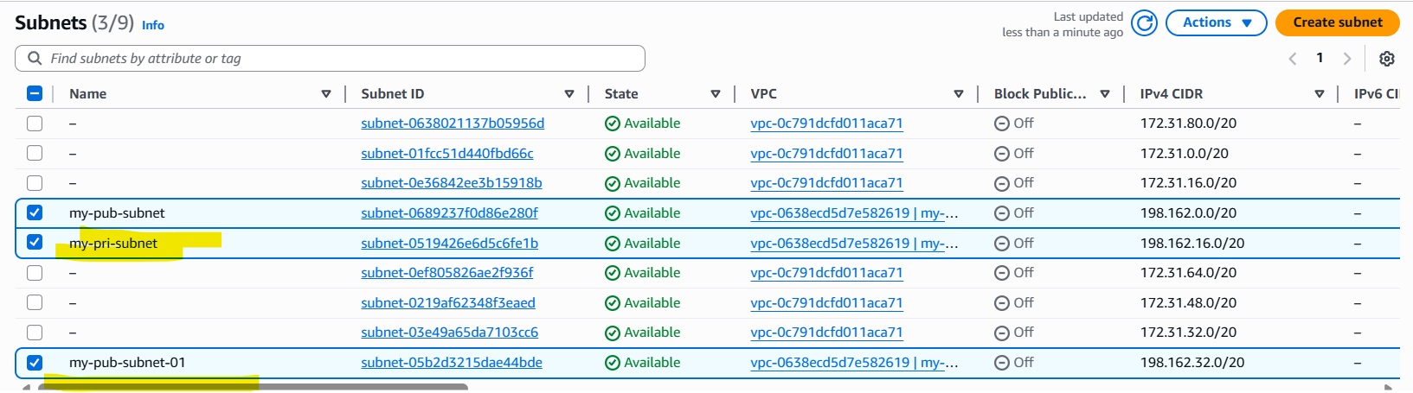
Step 2: In public route table, navigate to Subnet associations and attach the newly created subnet.
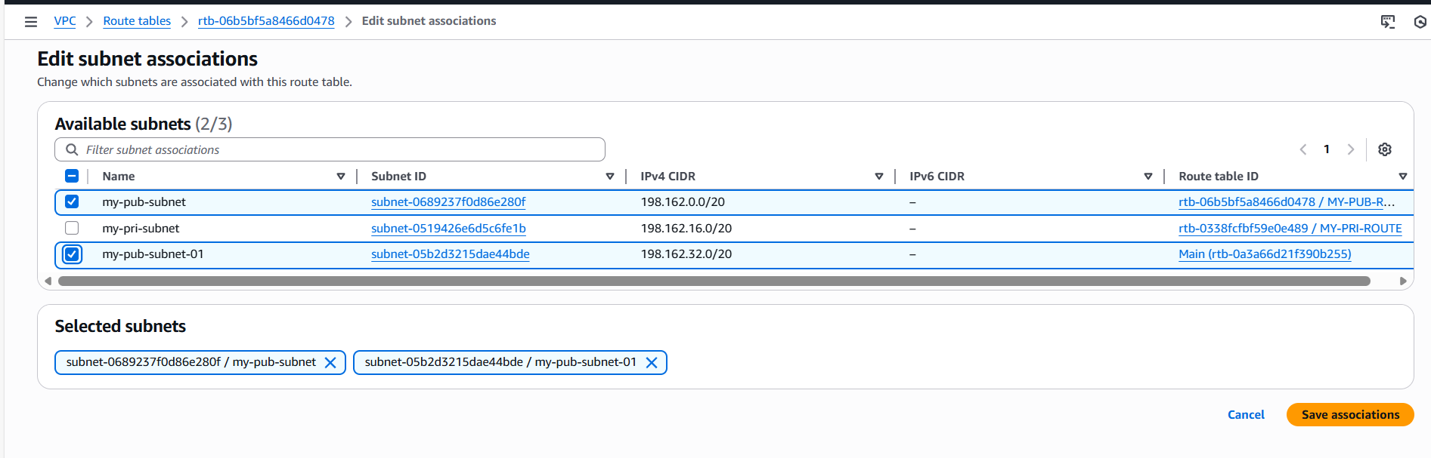
- Attached two pub subnets to the public route table.
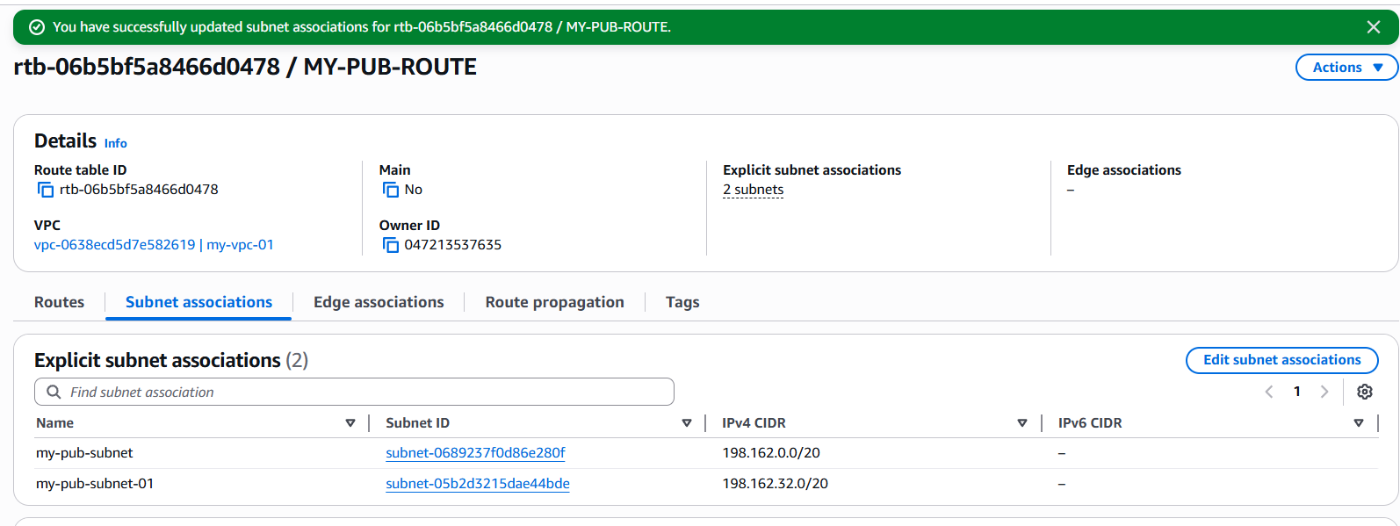
- However, previously we have attached NAT gateway to private route and Internet gateway to public route to public subnets.

Step 3: Navigate to ec2 and select Load balancer as a service and create one.
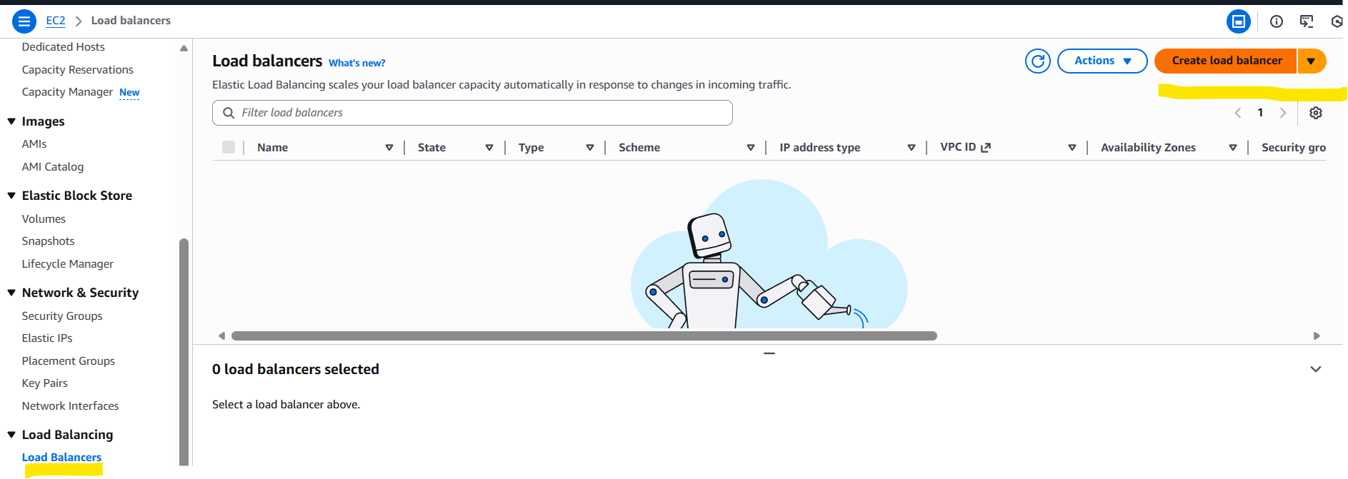

Step 4: Select Load balancer application as an option
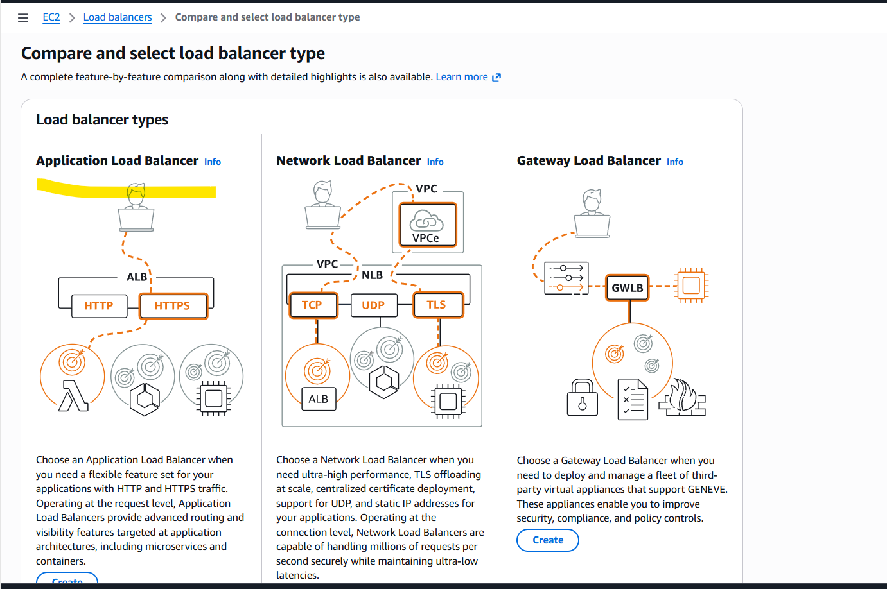
- Give a name to the Load Balancer and select- Internet facing as scheme.
- Load balancer IP address type is- IPv4
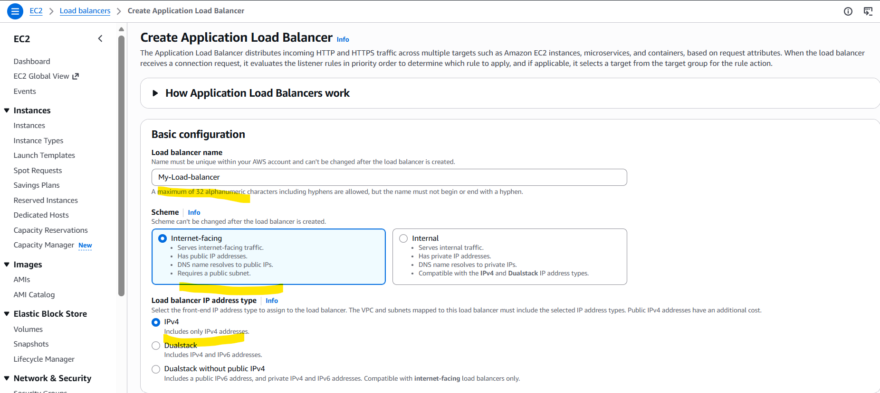

- Update network mapping to reflect the VPC and 2 public subnets in 2 different regions

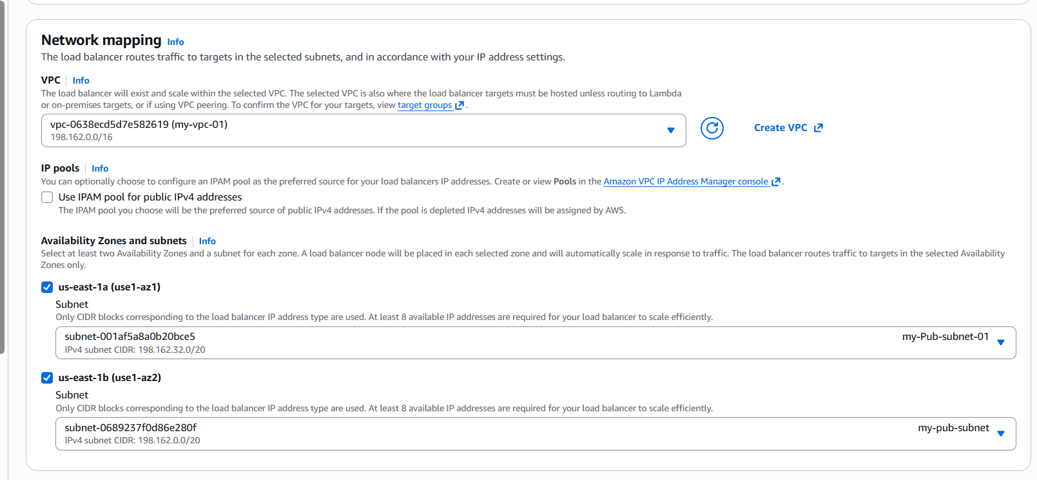

Step 5: Select Listeners and see if there is a Target group. There is nothing, because we need to create one. Let’s create one.

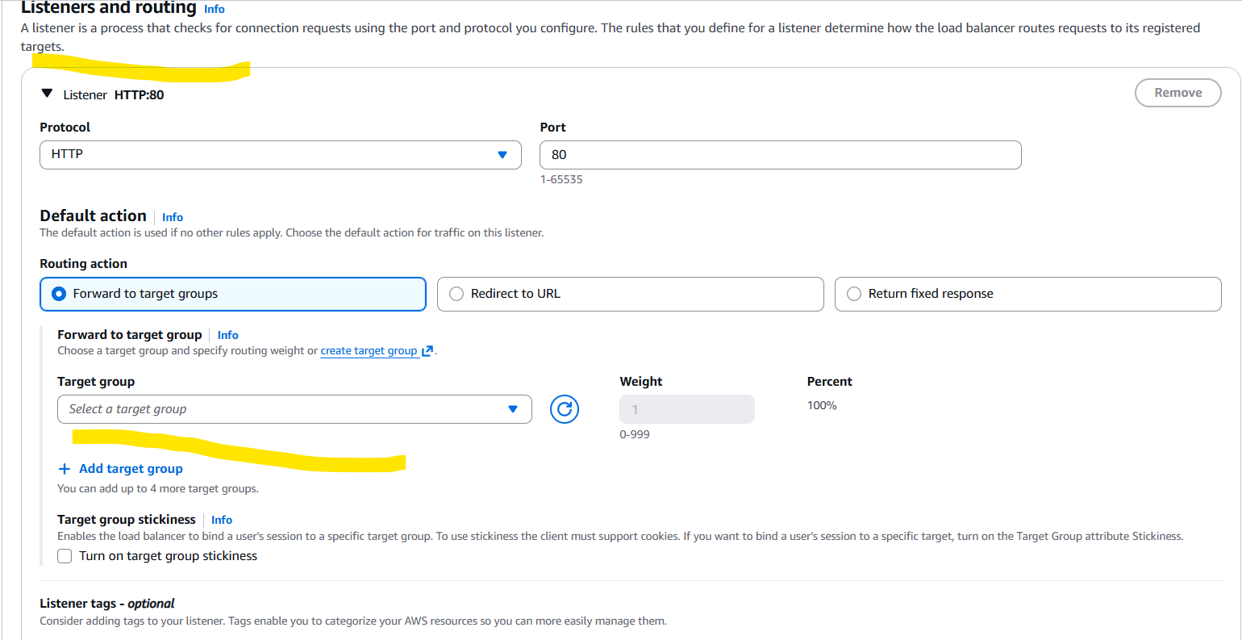

- Navigate to ec2 Target Groups create a new one.
- Select Instances and add a name to Target groups
- Select HTTP and port number 80 to continue.

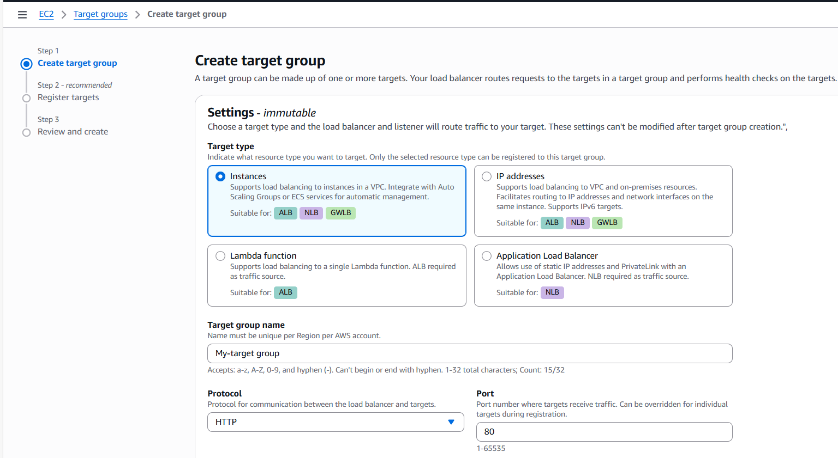

- Select the VPC and continue to next.
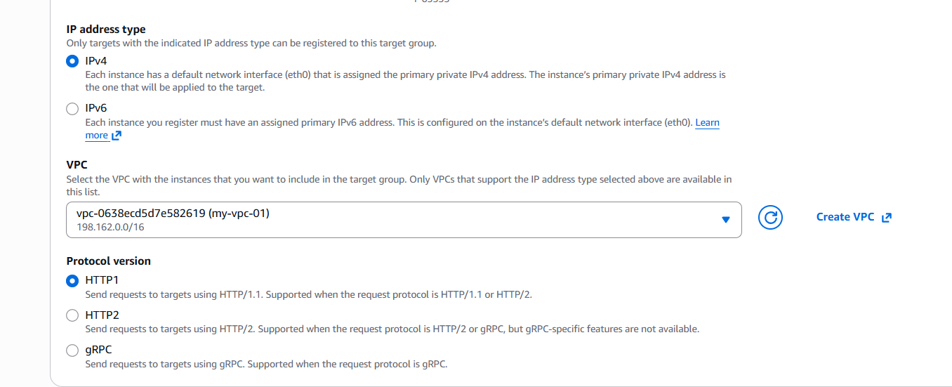

Step 6: select the two instances running and continue.

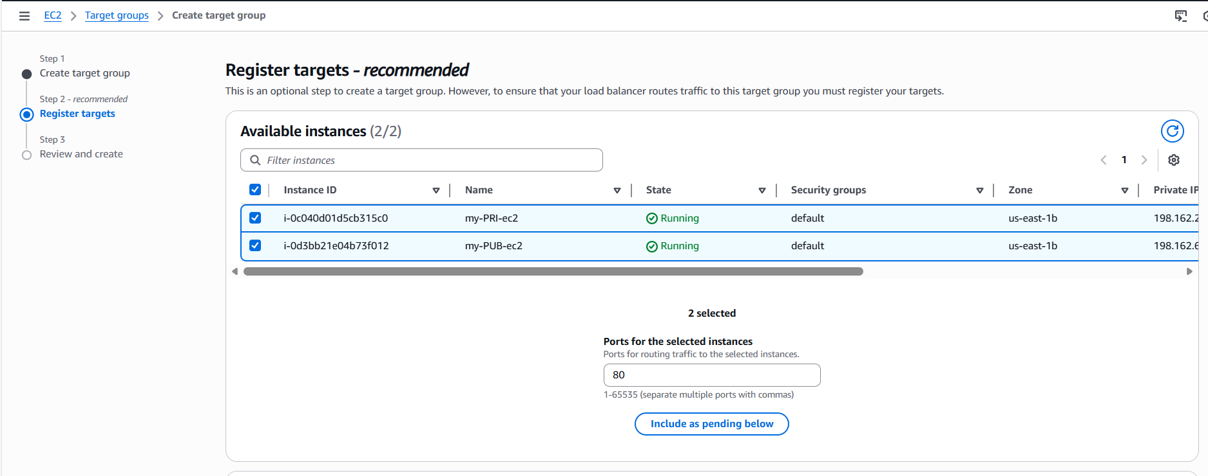

- Continue and create a new target group.
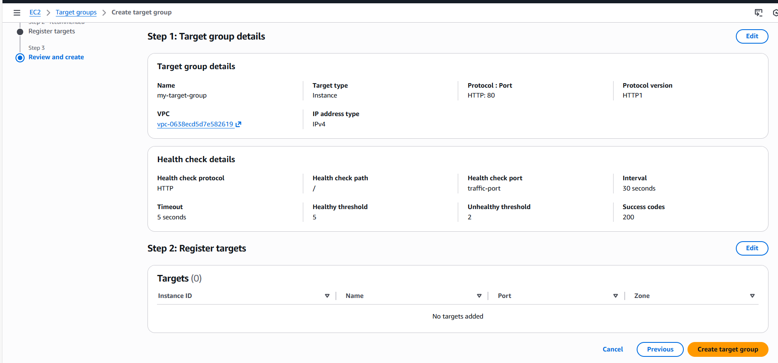

- Target groups have been successfully created and health checks are 0.

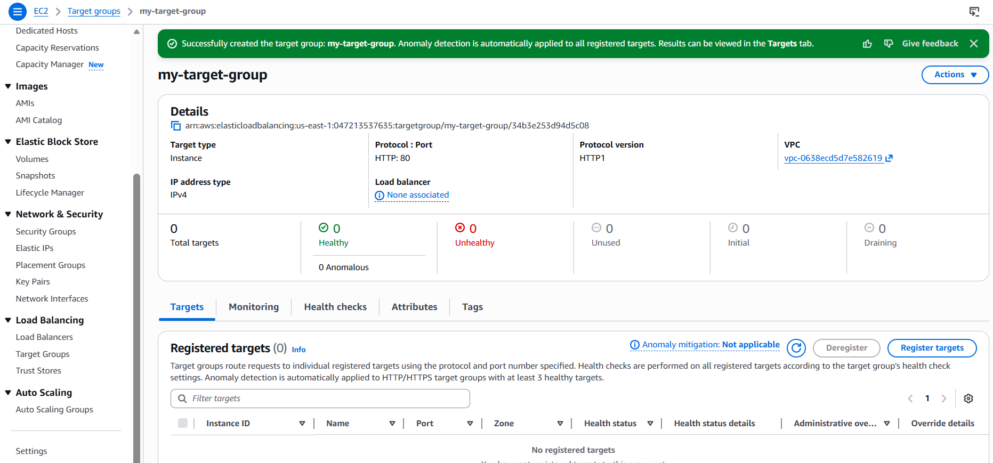

- Note: Navigate to Register targets and select the 2 instances if there is an issue while creating the Target groups.
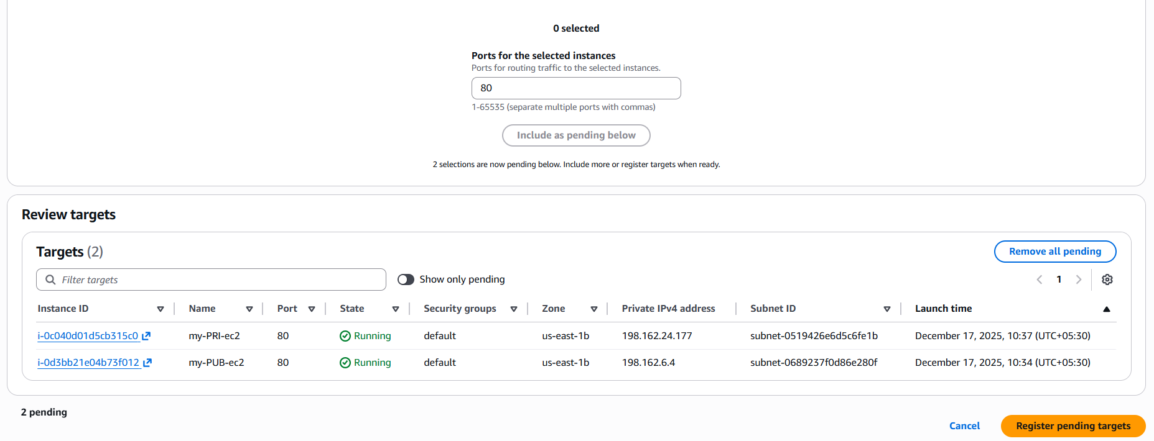

Step 7: Now back to Load balancer to attach the Target groups created.
- We were successfully attach the Target groups and lets go ahead and create the load balancer.
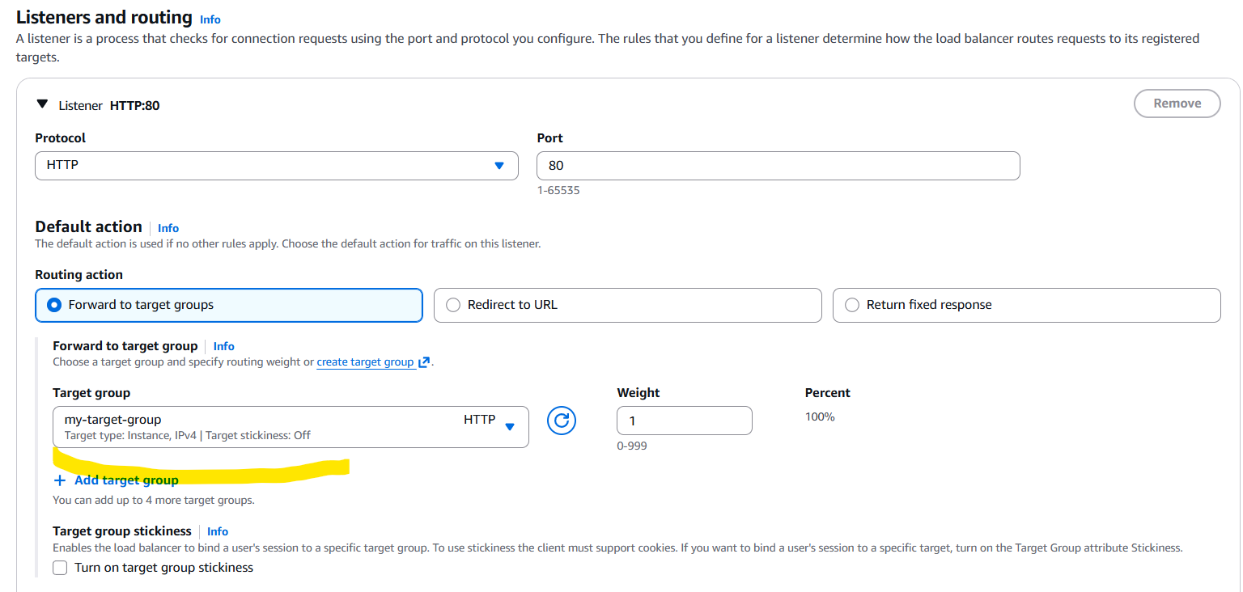

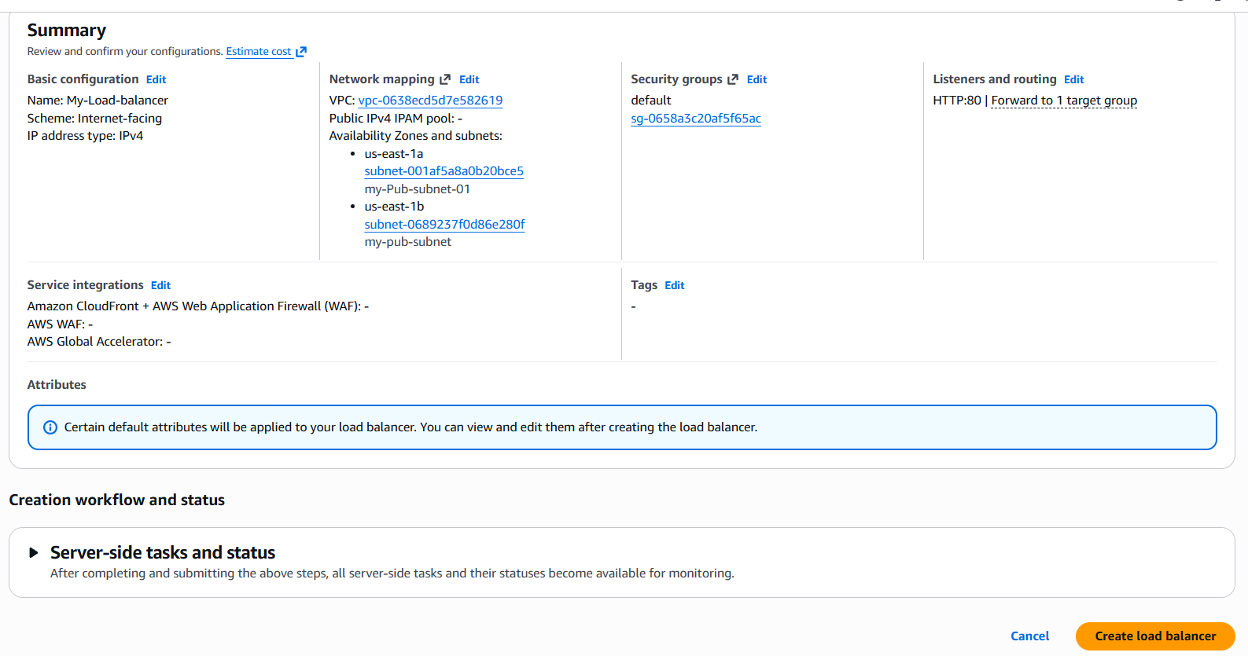

Step 8: Load balancer created successfully by attaching 2 public subnets and 2 ec2 instances to control the traffic flow for my application Load balancer.

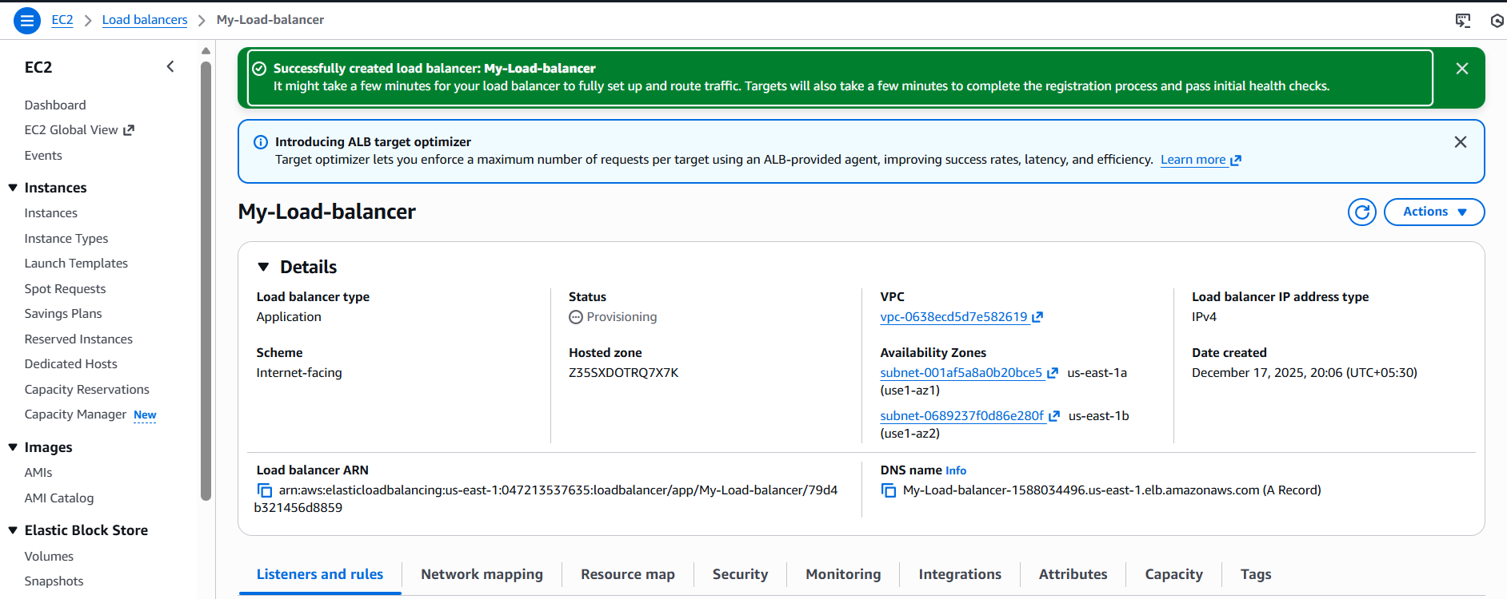

Step 9: Now its time to verify if the Apache package is working as expected.
- Click on the DNS link and copy the link and paste in the browser.
- It should display the private instance and once again if you refresh the same page, it should display the public instance.
Private ec2 page
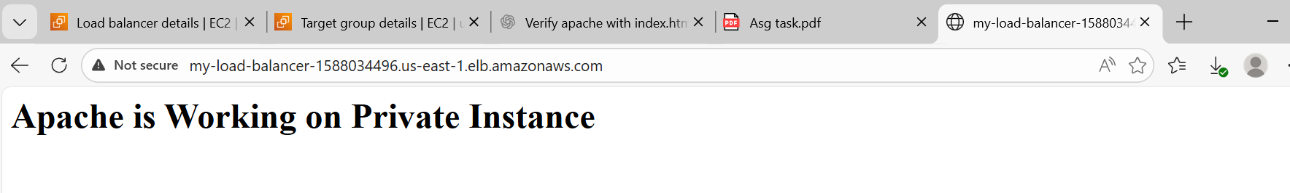

Public ec2 page
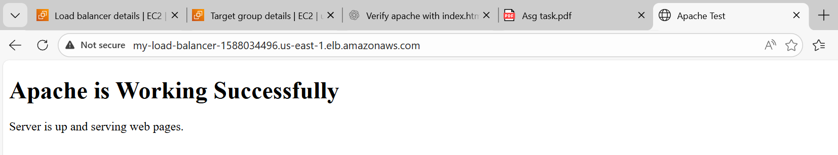

Conclusion:
We need to make sure to have Apache index.html file updated and deployment location updated and permissions provided.
If else, health checks might fail and we need to re-verify vpc, subnets, security groups.

- Store application load balancer logs in S3.

Objective:
The objective of this tasks is to configure Application load balancer (ALB), so that all logs are stored in S3 aws.

Prerequisites:
- S3
- Application load balancer

Step by step Implementation:
Step 1: Navigate to s3 and create a bucket with all defaults and no changes.
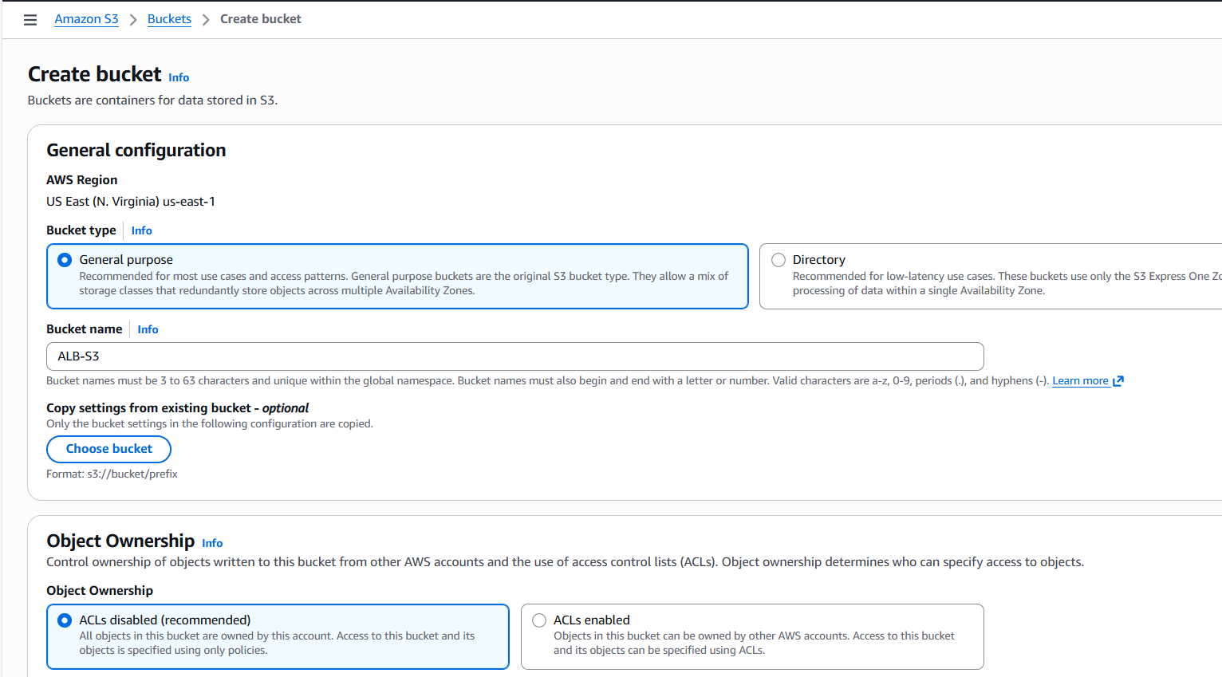
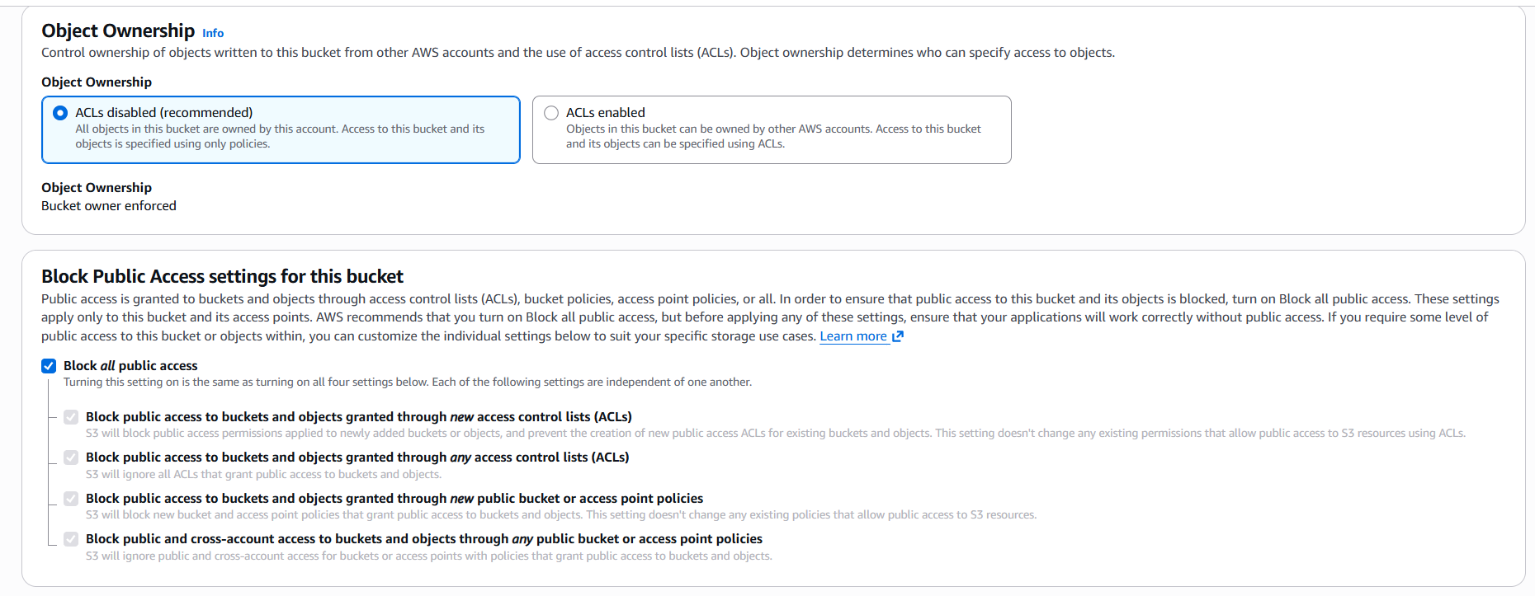
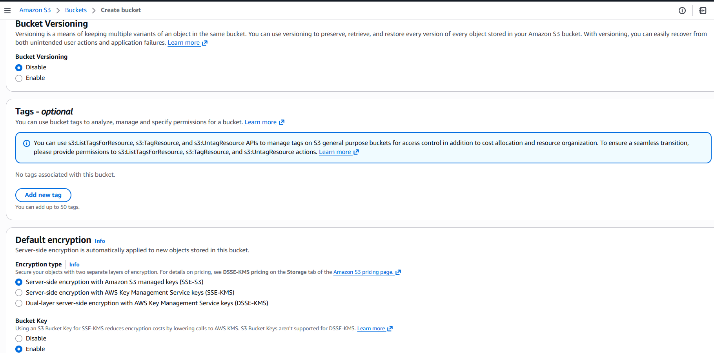

- Bucket created successfully.
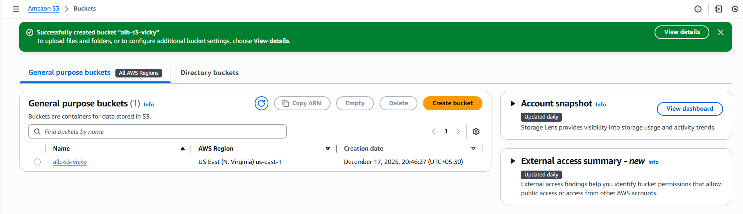

Step 2: Now, we need to provide permissions to allow logs to be transferred from Application load balancer to S3.
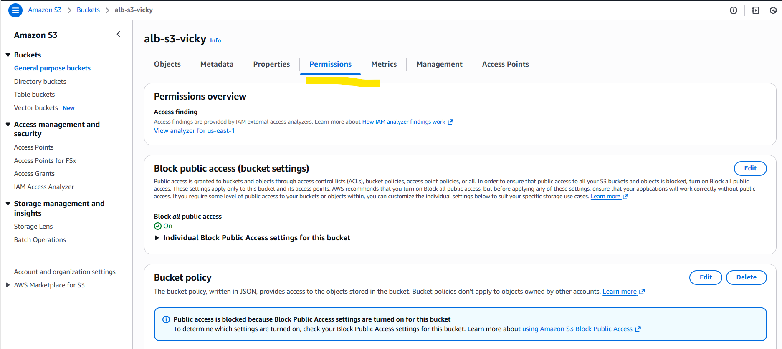
- Navigate to permissions tab and update json policy. The below is the policy attached.

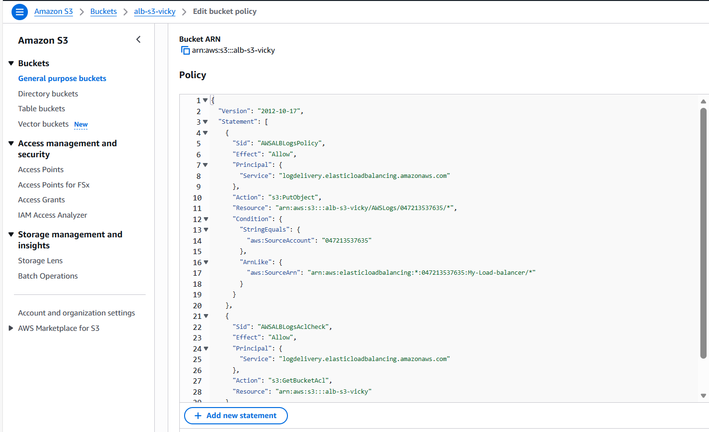

Step 3: Navigate to Load balancer in Ec2 and select attributes tab and proceed
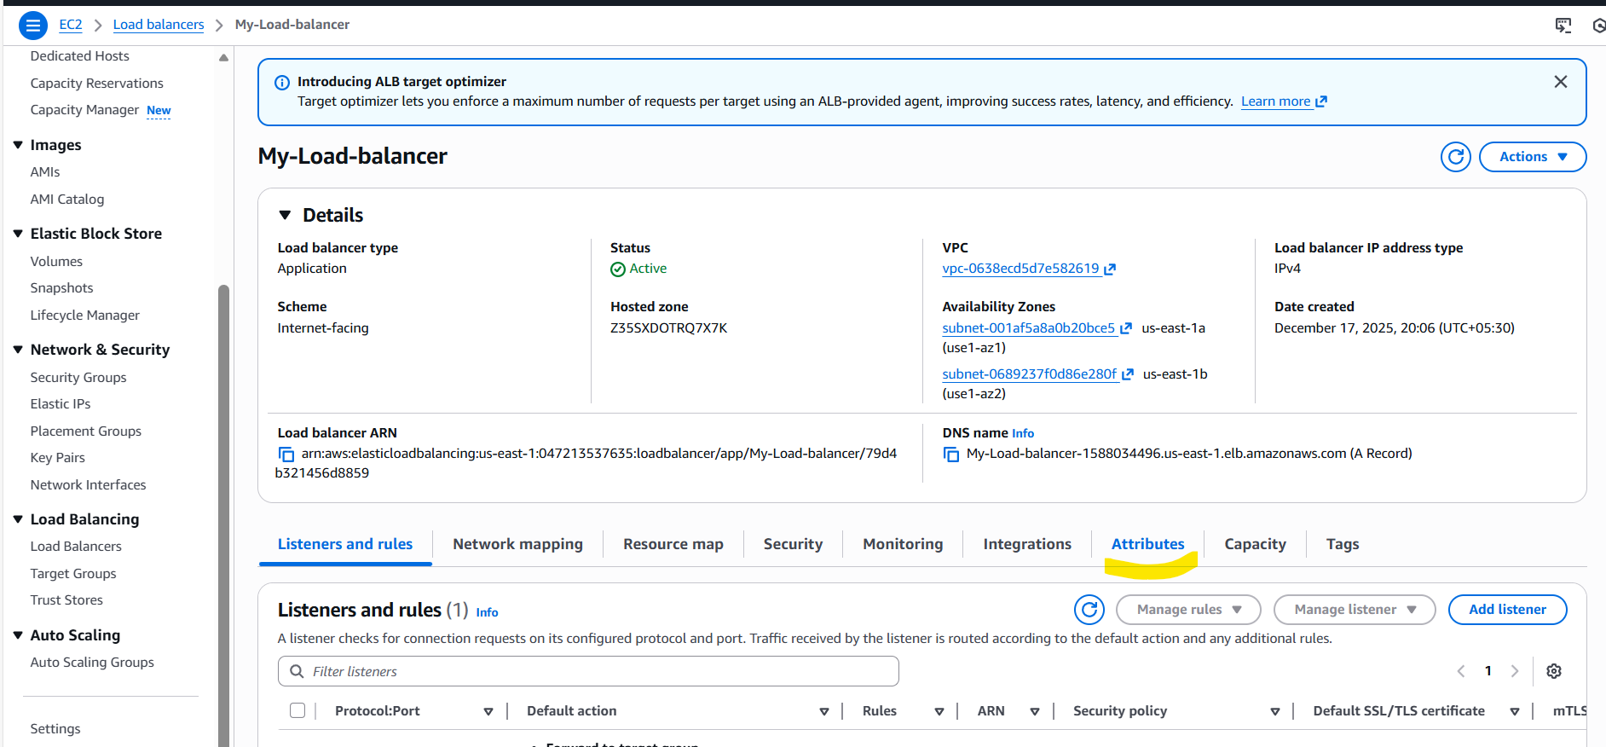
- Next, scroll down below and select Monitoring access logs.
- Since, there are no objects in s3, saving changes.

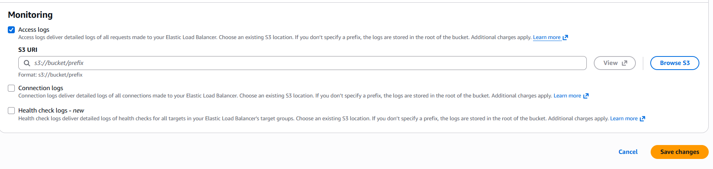
- Issues:
In the initial while creating bucket, we didn’t enable ACLs and Block access as well to public and other AWS resources.
Updating them back in S3.
Block access removed and saved.
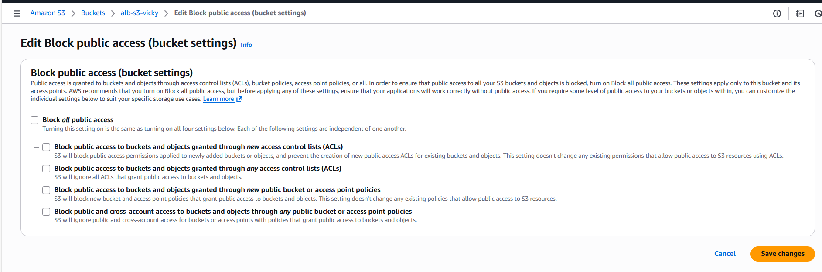

Access Control list is enabled now as well.
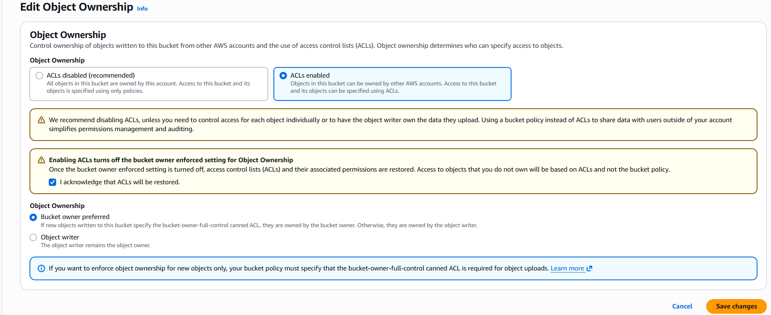

Finally, we can see the Load balancer is updated below.
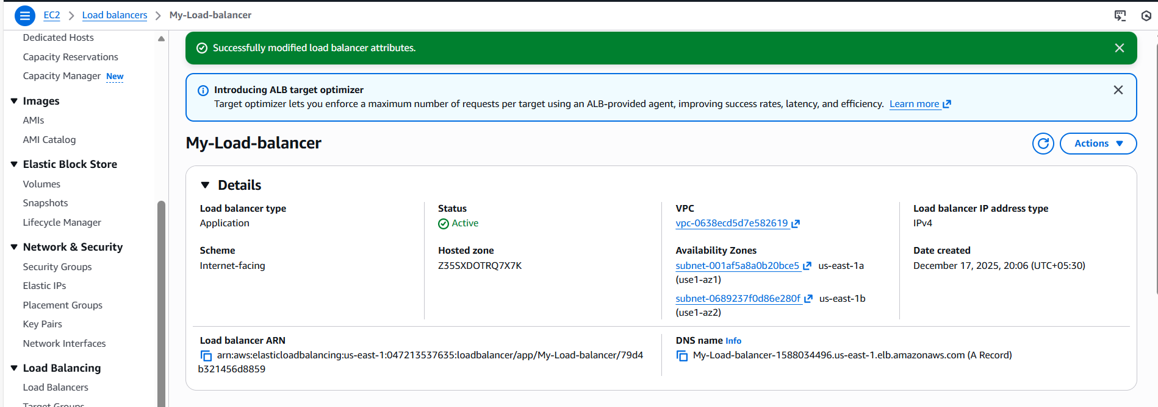

Conclusion:
This setup improves application observability, enhances operational monitoring, and ensures compliance with logging best practices.

- Store the VPC flow logs in a CloudWatch log group.

Objective:
The objective of this task is to store the VPC flow logs to CloudWatch log group, so that it will record all incoming + outgoing traffic inside our VPC (like who connected from which IP, port, etc).

Prerequisites:
- VPC
- CloudWatch

Step by step Implementation:
Step 1: Navigate to VPC and create a flow log.
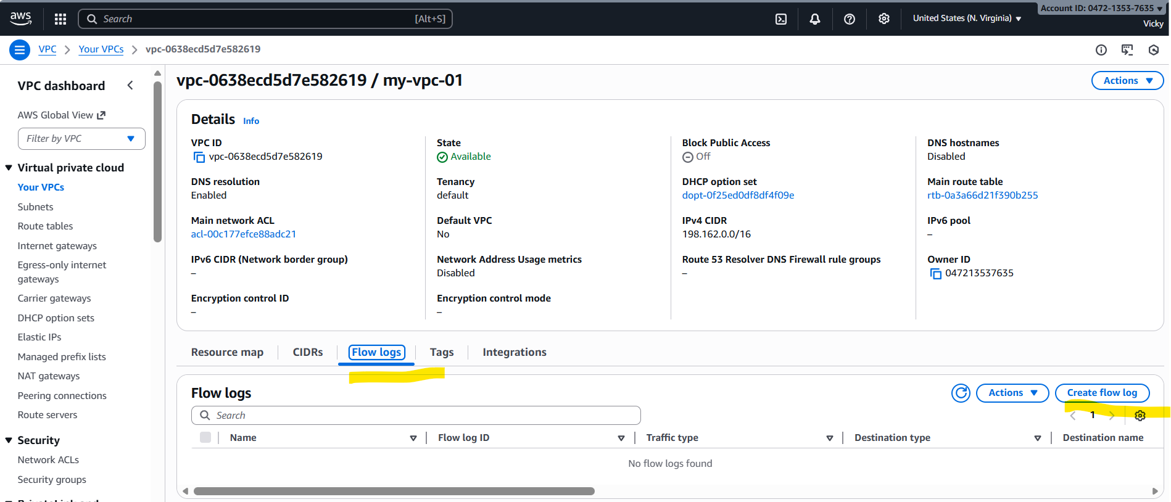
- Filter: All
- Interval: 1 Minute
- Destination: Send to CloudWatch logs
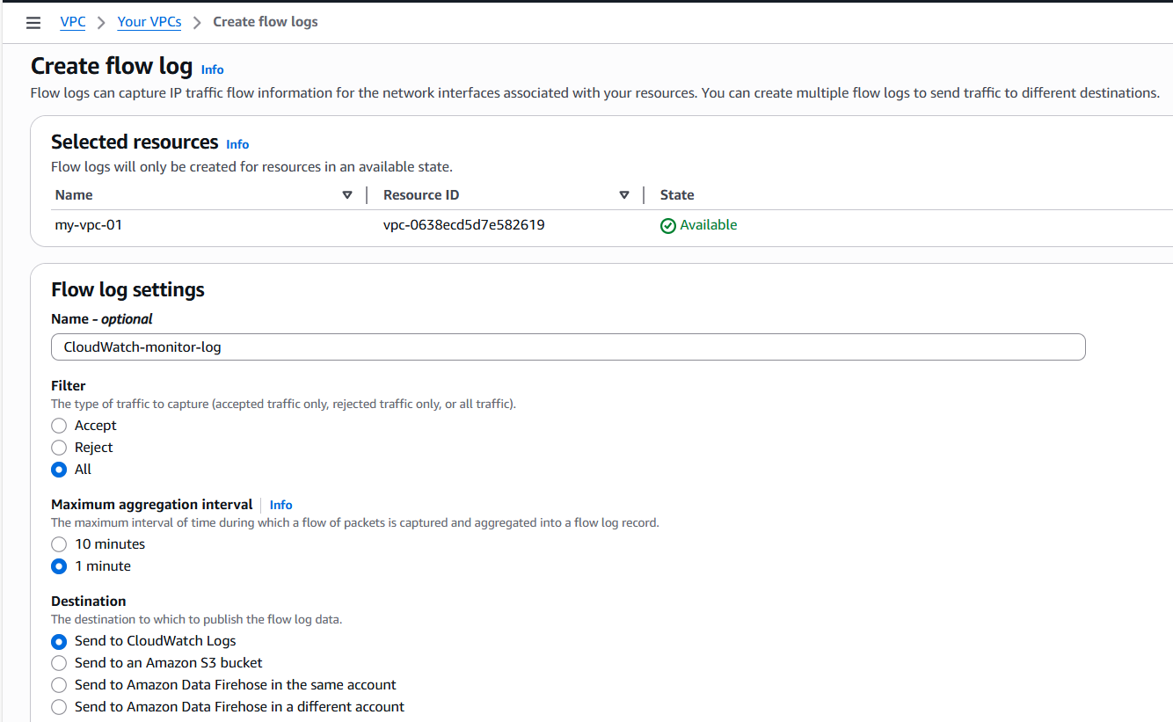

- Destination log group: created a new one
- Service role name: Created a new one and assigned automatically.
- Continue next and create one.
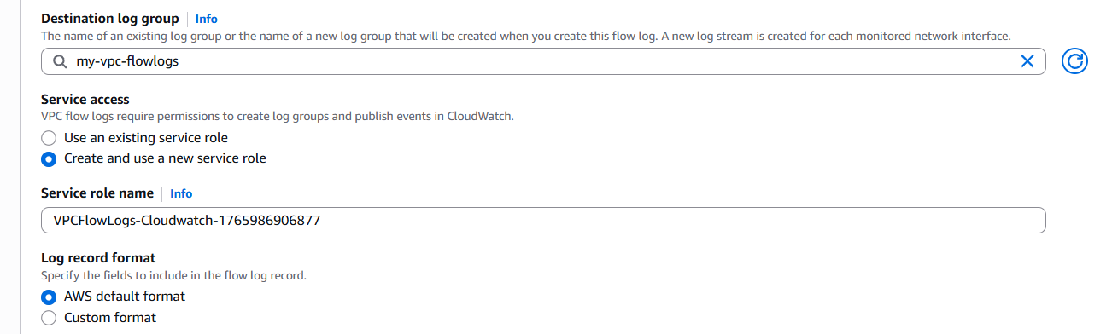
- Created successfully.
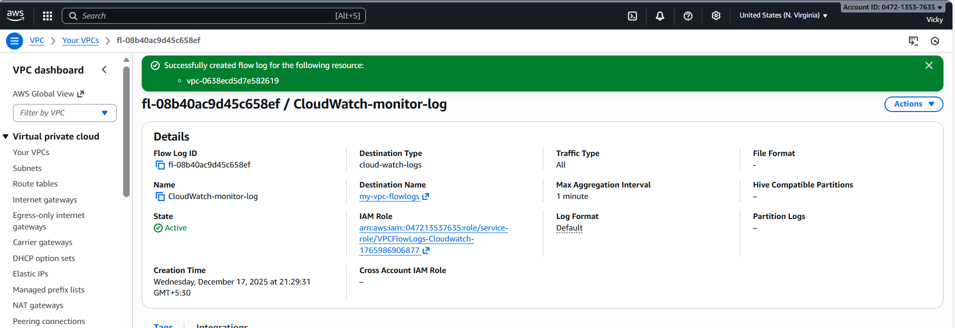

Step 2: Now let’s navigate to CloudWatch and verify if the flow logs are created.
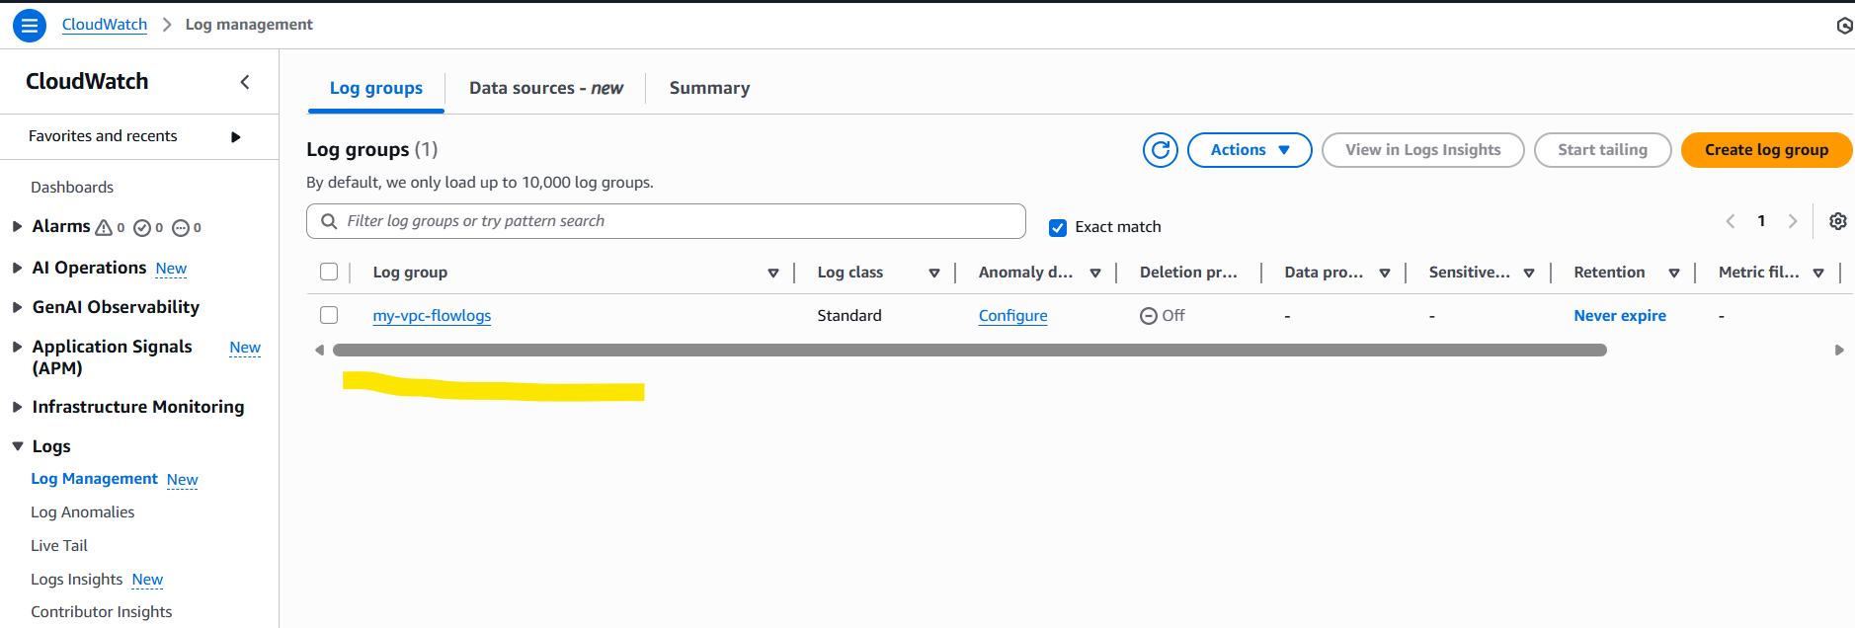

- We can verify that; flow logs are getting transferred successfully from VPC to CloudWatch.
- Task completed successfully.
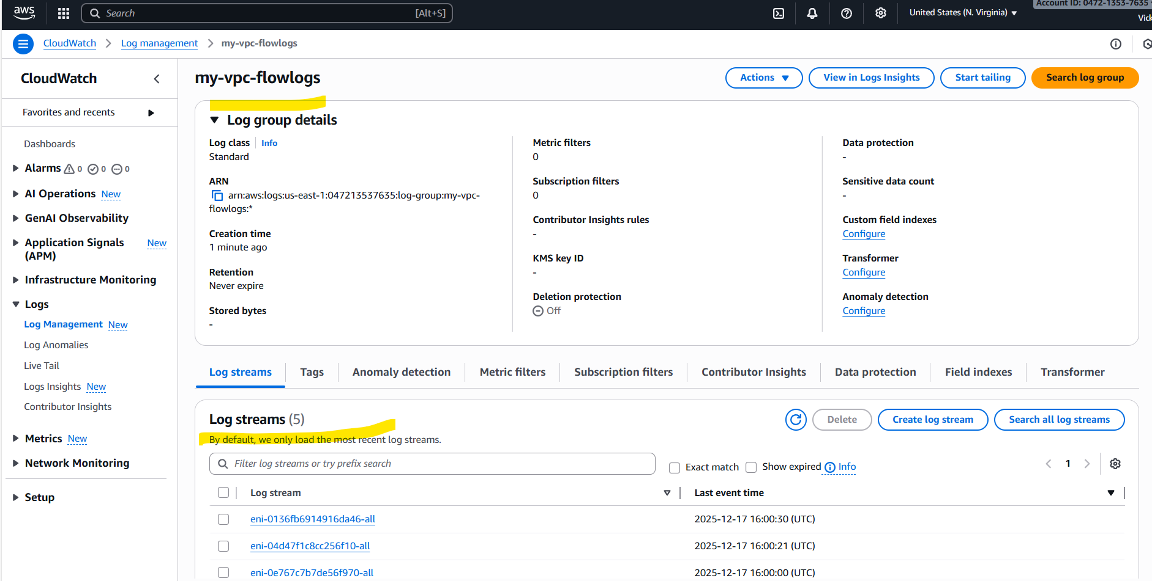

- Create monitoring dashboards to monitor CPU utilization and to monitor the Apache service.

Objective:
The objective of this task is to monitor CPU utilization and monitor Apache service by creating Amazon CloudWatch dashboards that track the observatory from the ec2 instances.

Prerequisites:
- CloudWatch
- EC2
- Apache package
- Cronjobs
- Bash script

Step by step Implementation:

Step 1: Navigate to CloudWatch and create a Dashboard in CloudWatch.

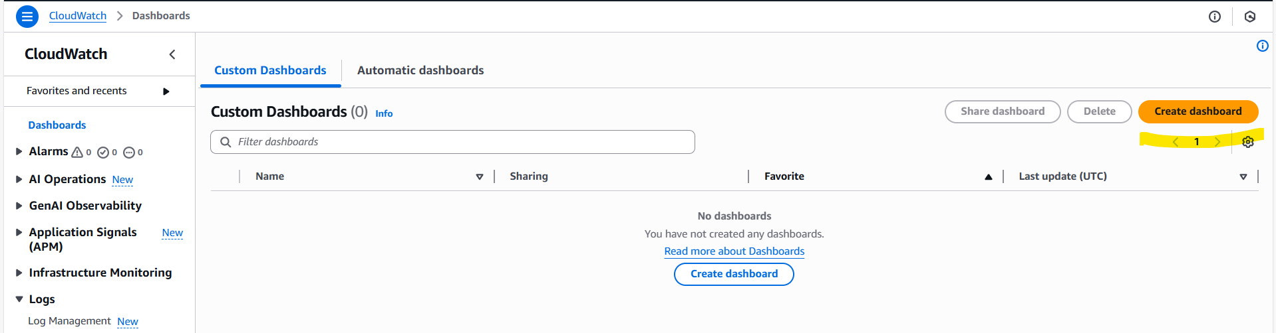

Step 2: Select Number from the metrics
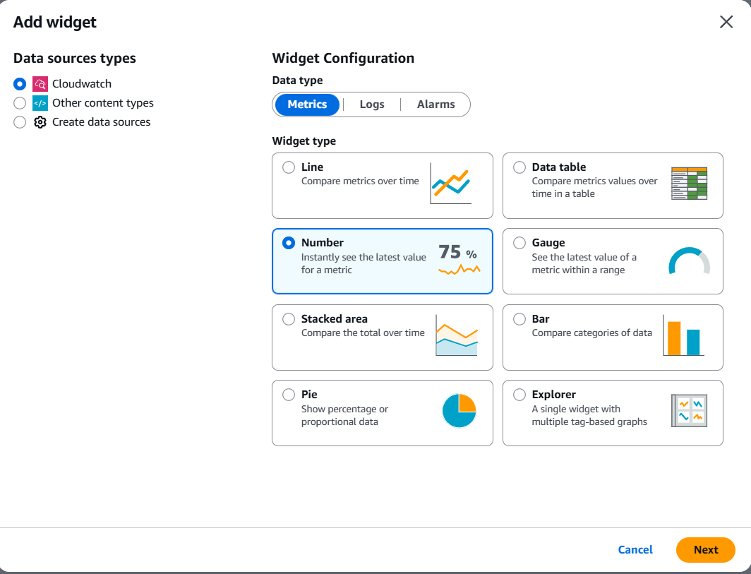

Step 3: Select ec2 from the list below and filter from Per-Instance Metrics.
- From the Per-Instance Metrics filter- CPU utilization.
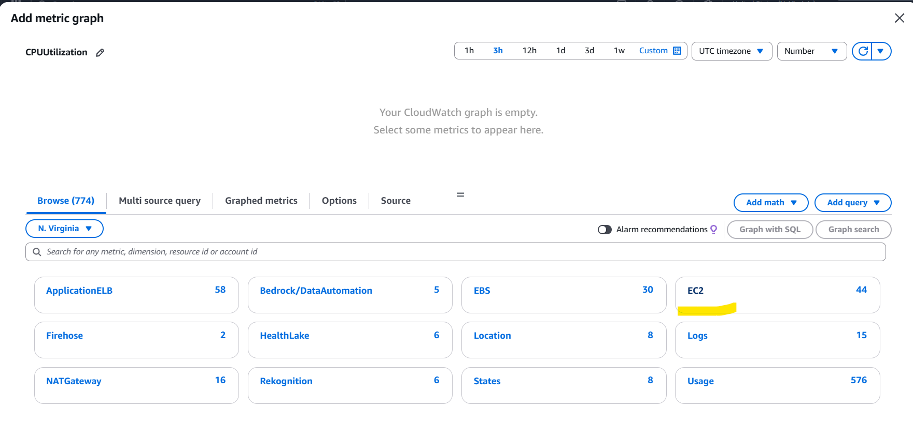
- Selected public ec2 instance to monitor the CPU and Apache server.
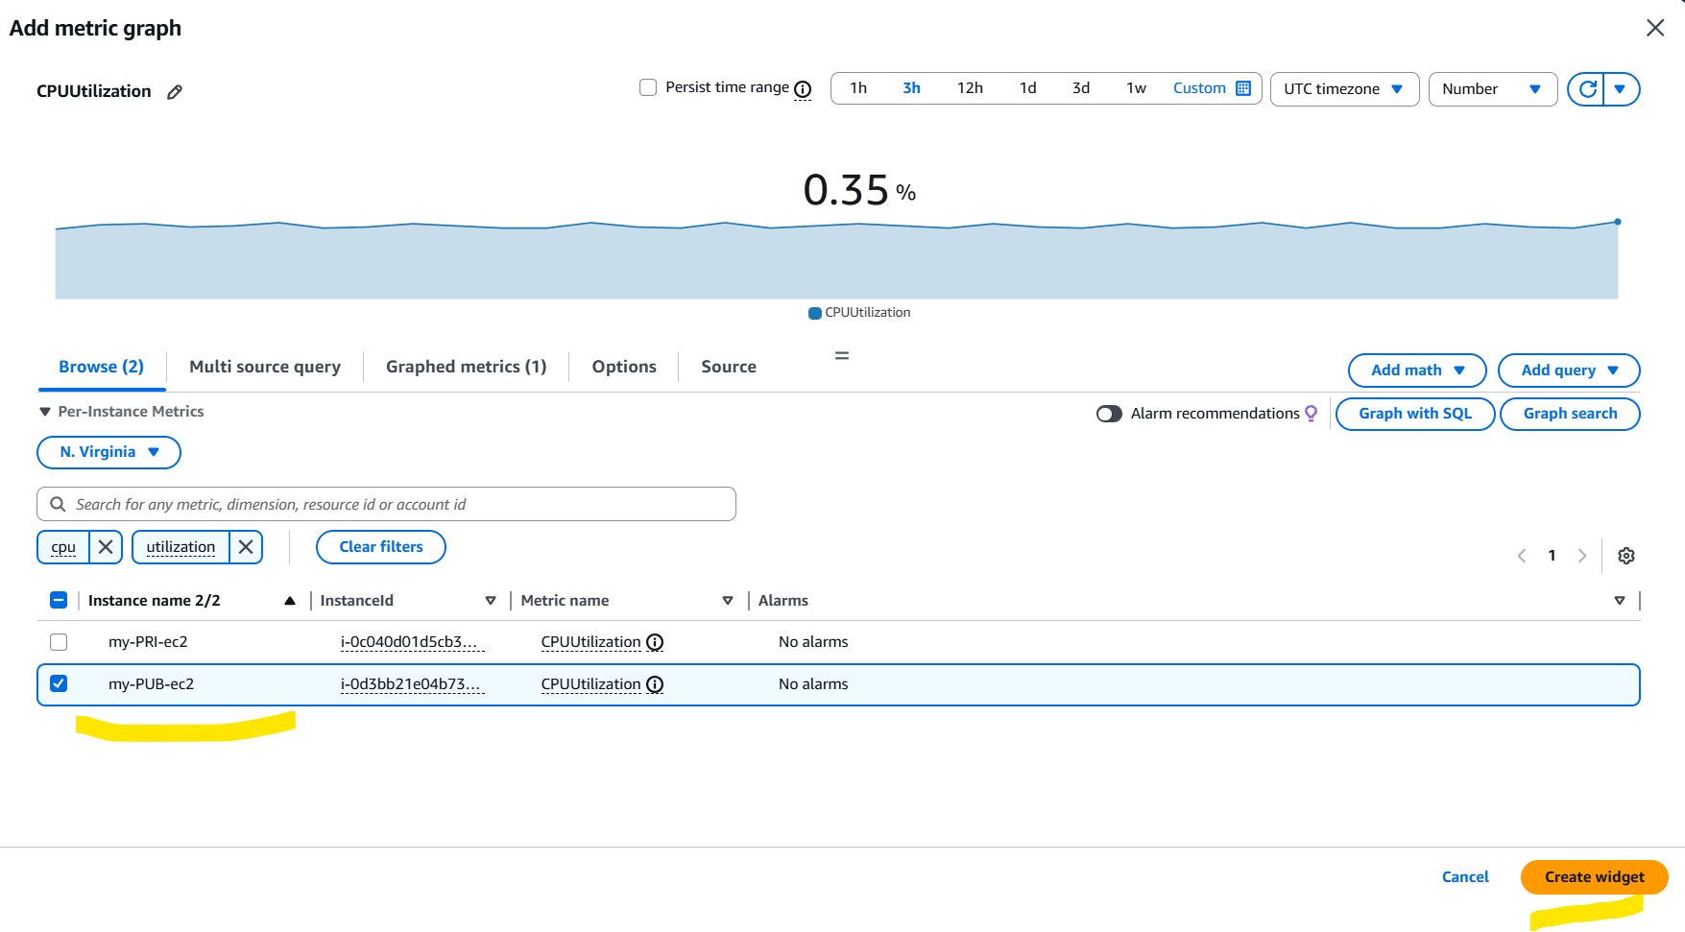
- Dashboard created successfully.
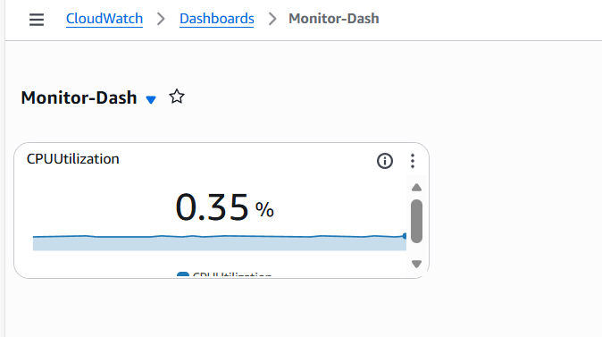
Step 4: Create a new bash script to monitor the Apache service in CloudWatch
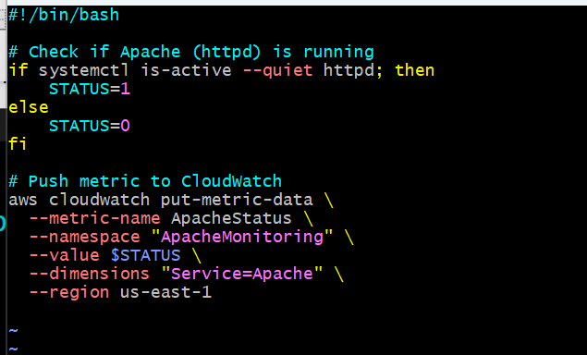
- Using Cronjobs- I wan to run the script for every 5 minutes.
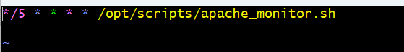
- Using Cronjobs, enabled the script to un every 5 minutes and permissions provided.
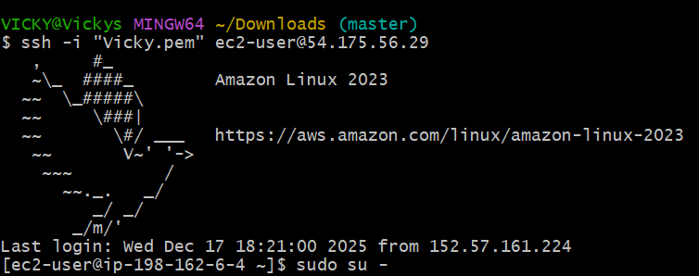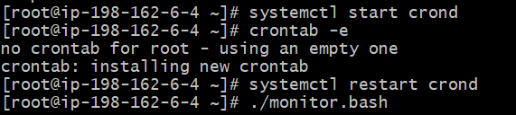
Step 5: Now, it’s time to navigate to CloudWatch and add Apache to Dashboard.
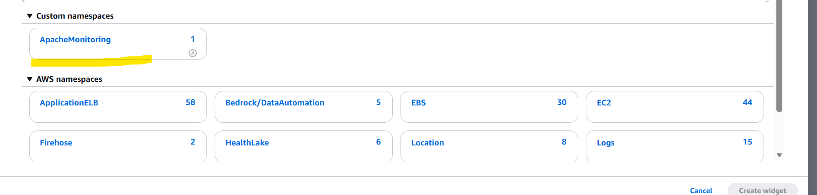
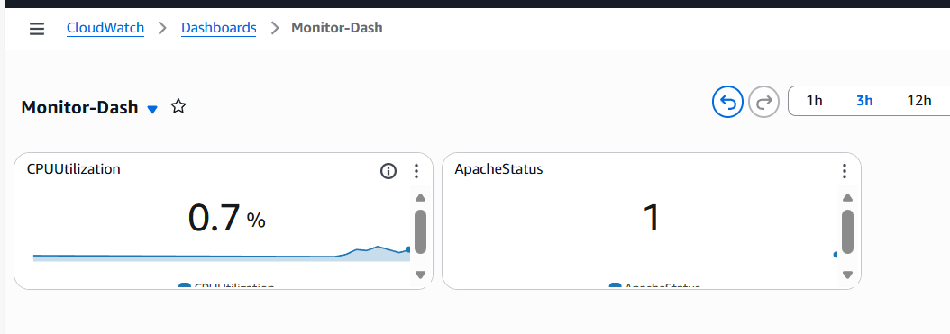

Conclusion:
CloudWatch monitoring was set up to track CPU usage and Apache service health, ensuring better visibility and quicker troubleshooting of the server.

- If CPU utilization is more than 70%, then it should trigger auto scaling and launch new instance.

Objective:
The objective of this task is to configure Auto scaling on AWS so that when CPU utilization is more than 70% then it should create new instances as per the traffic. This will ensure smooth and effective application running.

Prerequisites:
- EC2
- Launch Template
- Auto Scaling Groups (ASG)
- VPC
- Subnets
- Load Balancer
- Target groups

Step by step Implementation:
Step 1: Navigate to ec2 and scroll to the right select actions Image and Template Create Template from instance to get started.
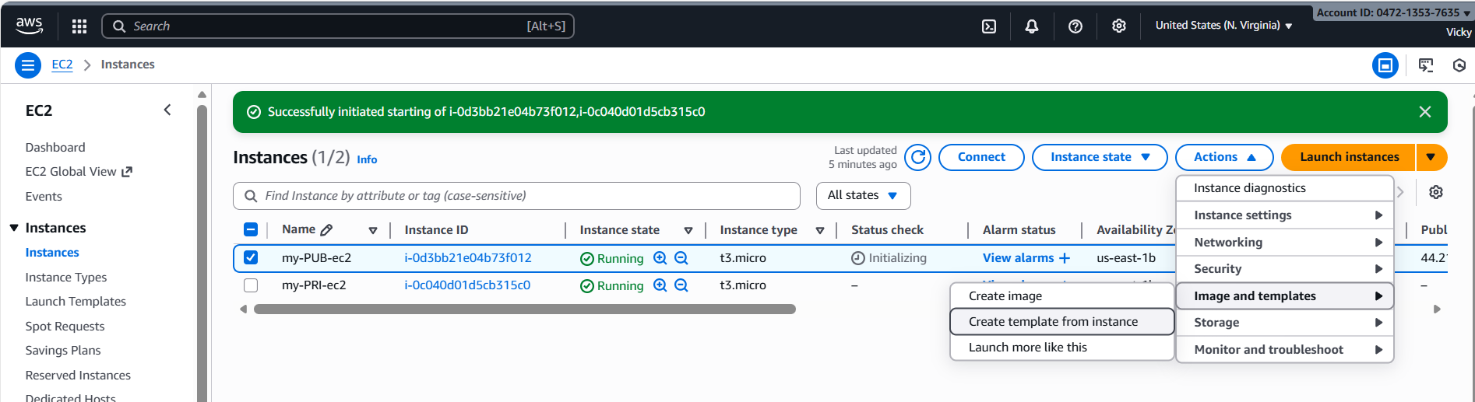

Step 2: Create the template by providing details- name, description and default settings and continue.
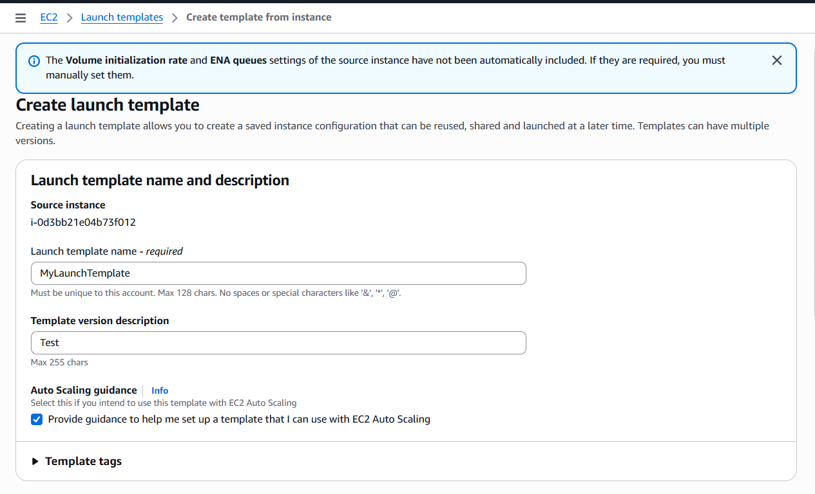
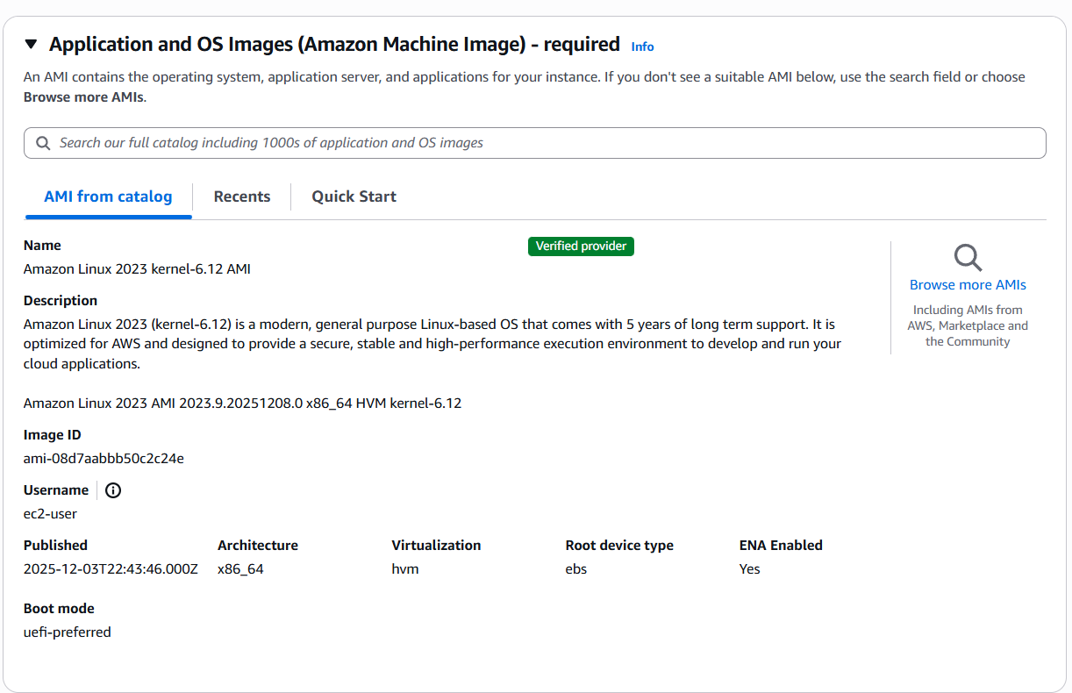
Note: Do not include subnets/zones as Autoscaling doesn’t need them.
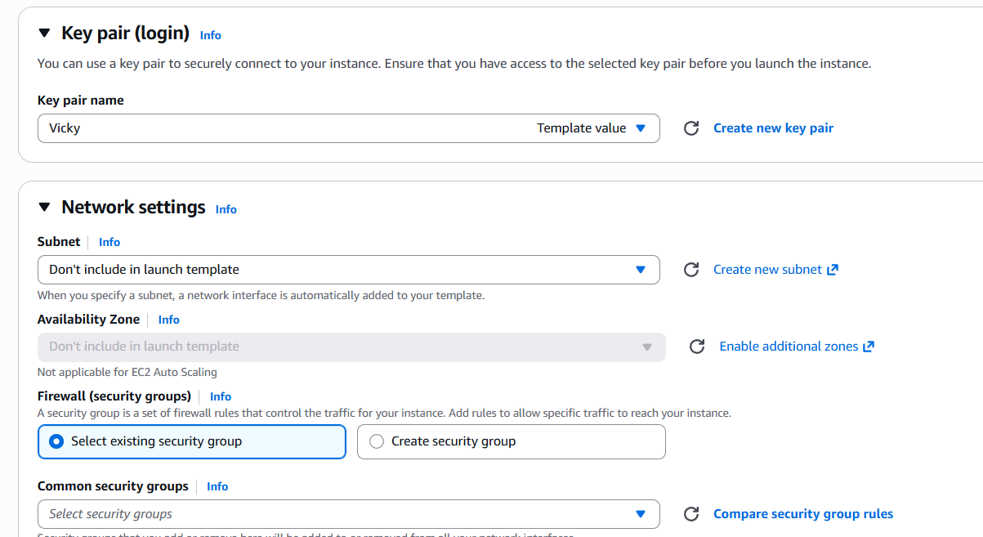

Note: Bash script is drafted to install httpd and start Apache on Launch template configuration.

- Successfully Launched Template from ec2 instance.
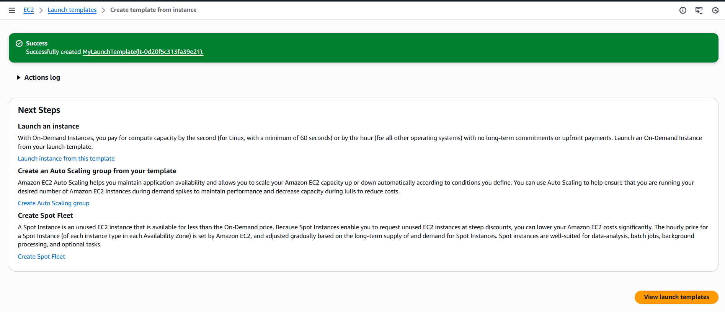
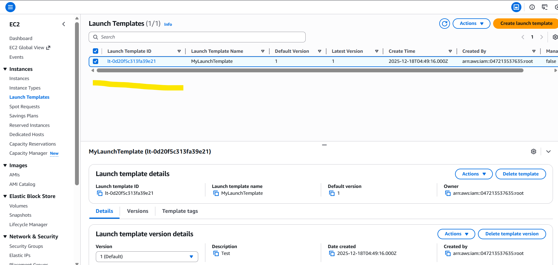

Step 3: Now, its time to navigate to ASG and update all details required as per expectations.
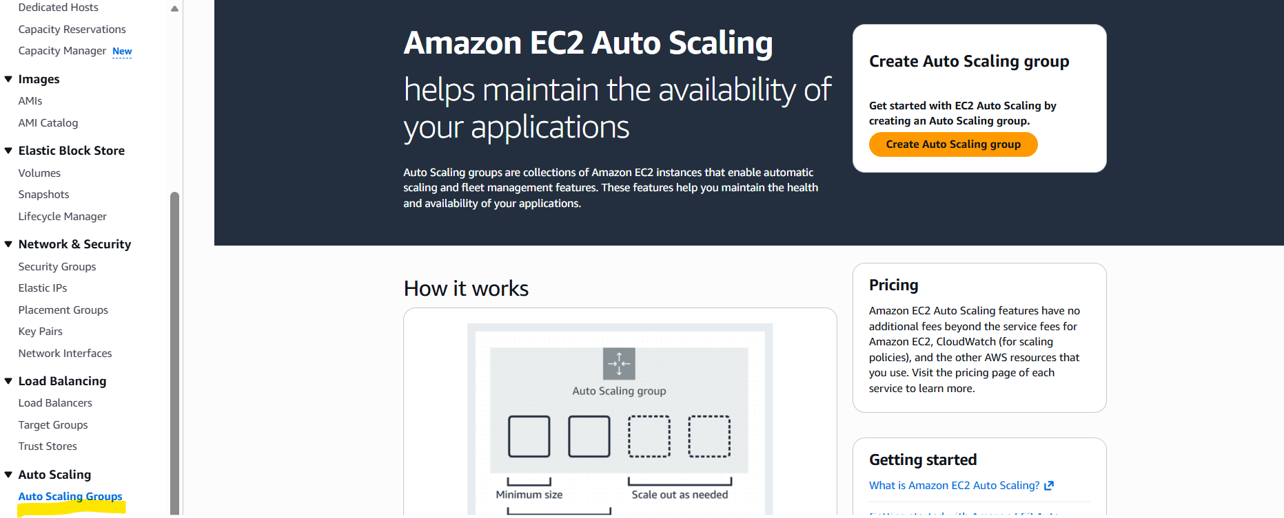
- Name the ASG and select the Launch template and save.
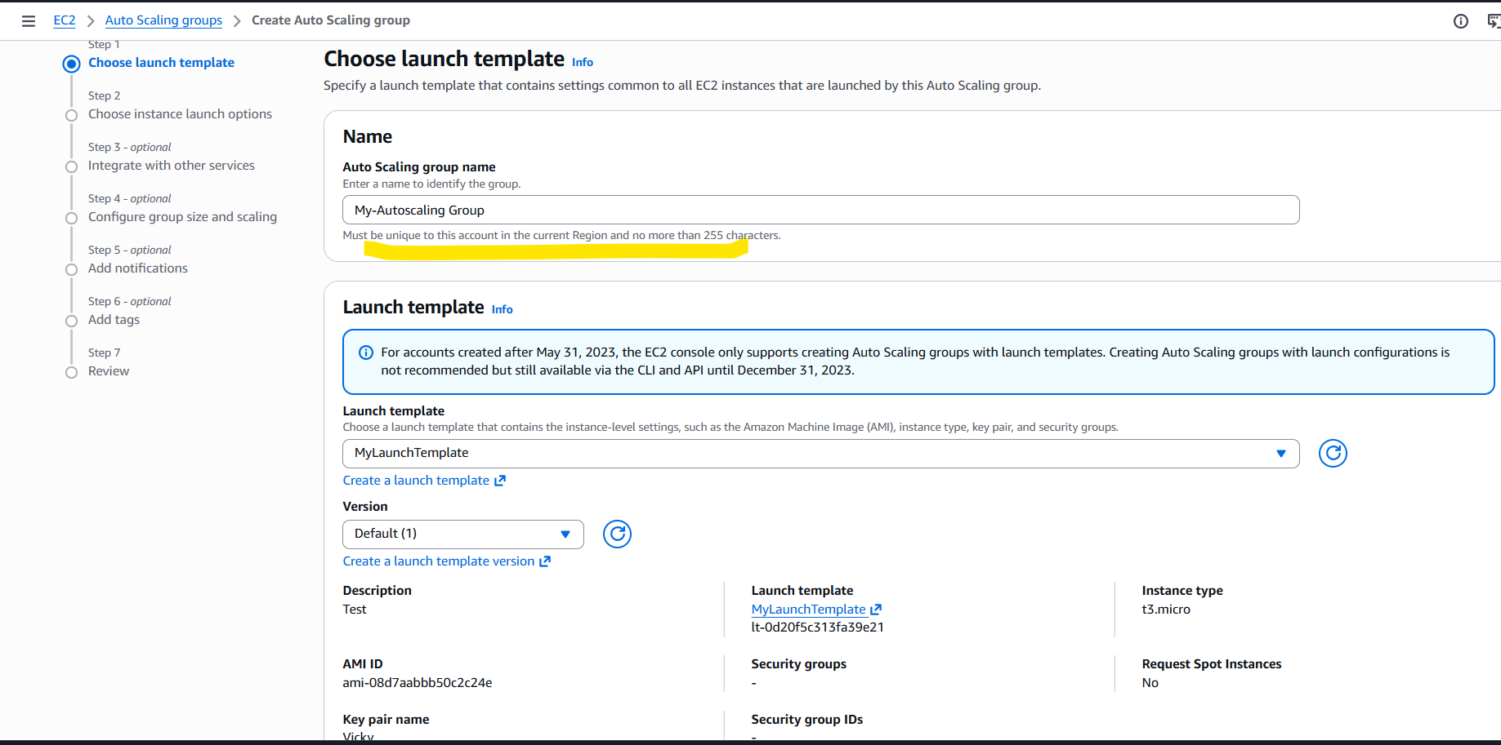
- Select the VPC and all subnets you have got for the instance and next.
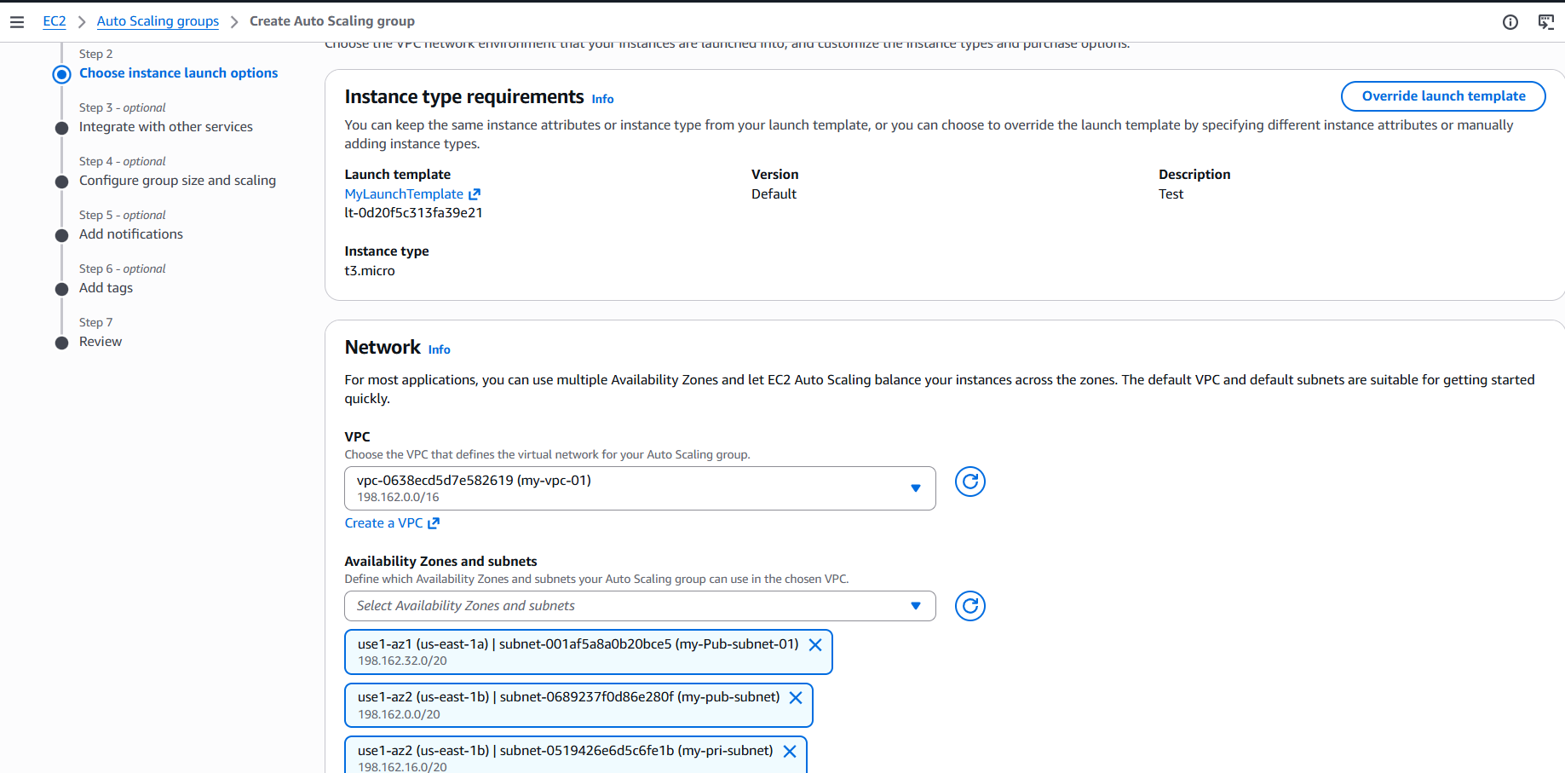

- Attach the existing load balancer and Target groups created earlier and continue next.
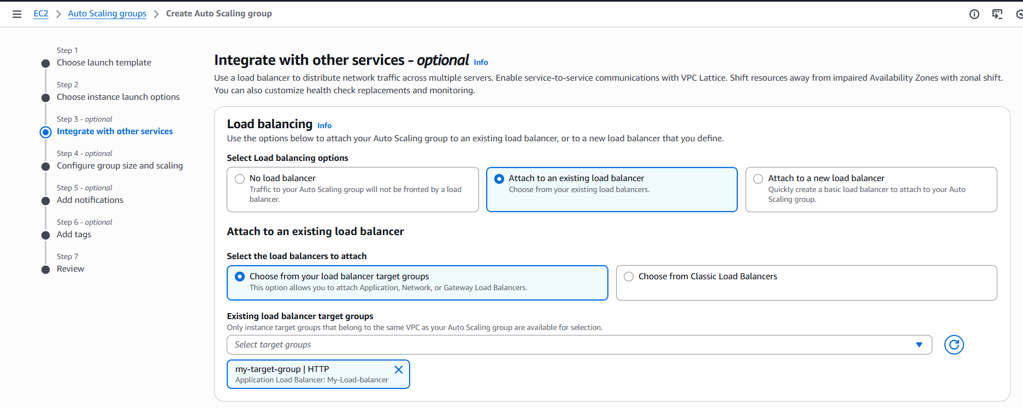
- Scaling the instances, I have automated 1 min instance, 5 max instances as per traffic.
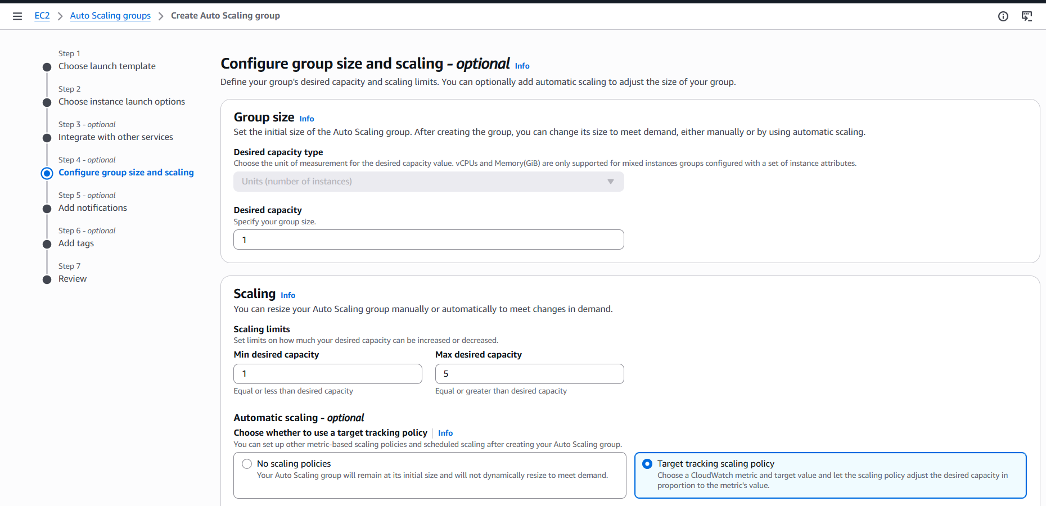
- I have targeted the scaling policy to monitor CPU Utilization for 50 when instance is up for 100 seconds.
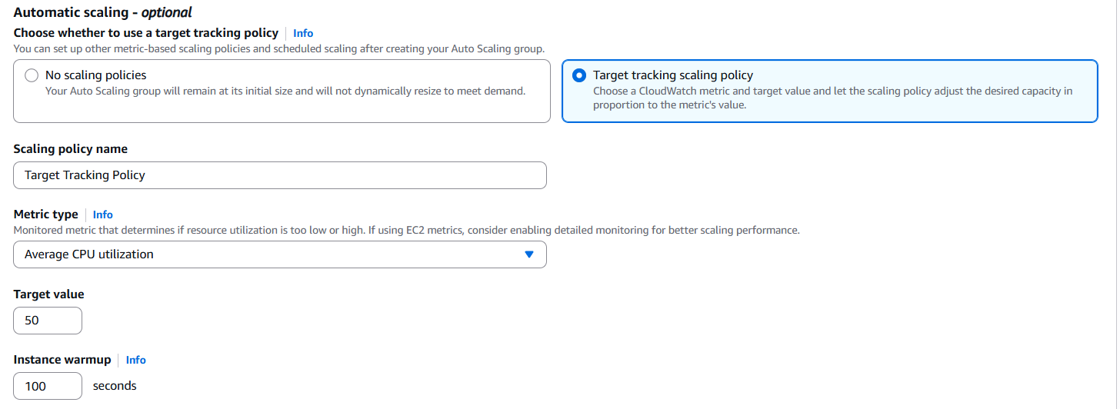

- ASG has been created successfully.
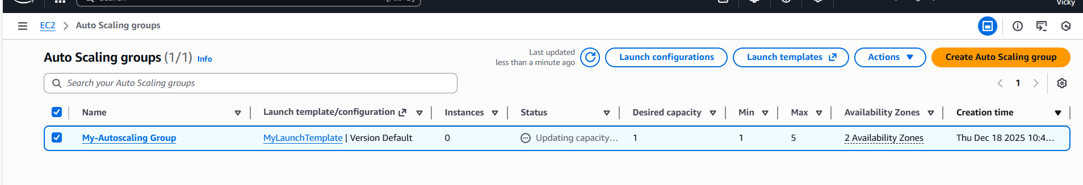
- We have enabled Metrics collection in CloudWatch.
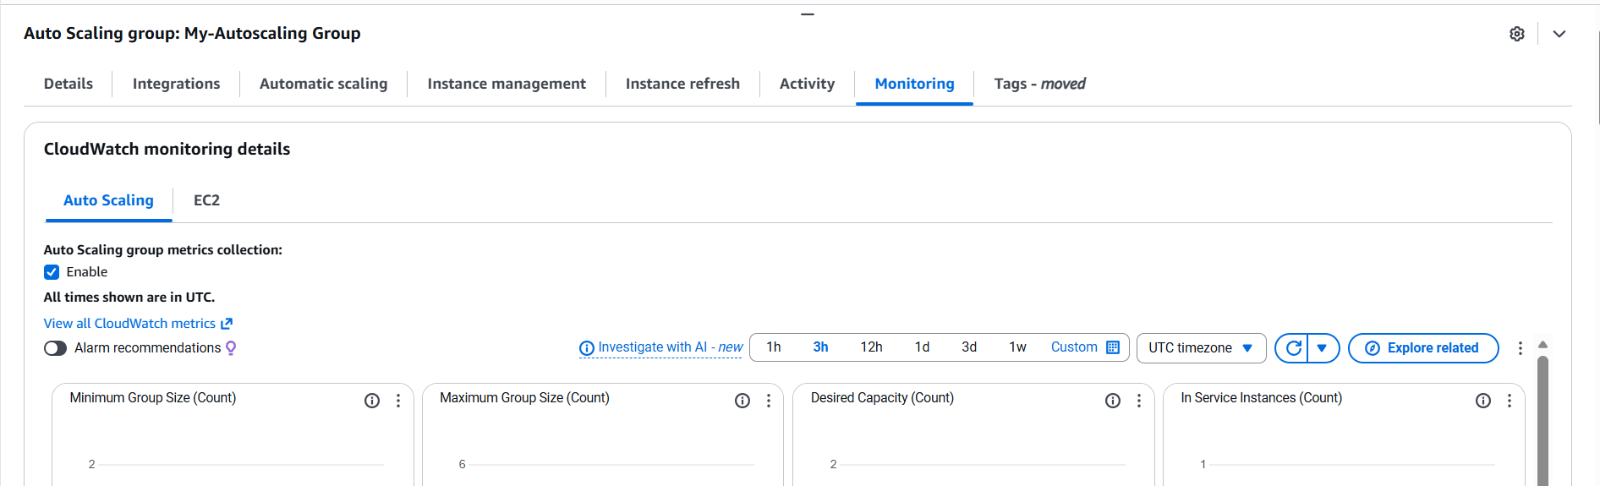
Step 4: Once ASG created, Navigate to ec2 and verify if any instance has been created.
As per my CPU utilization, one instance has been created automatically.
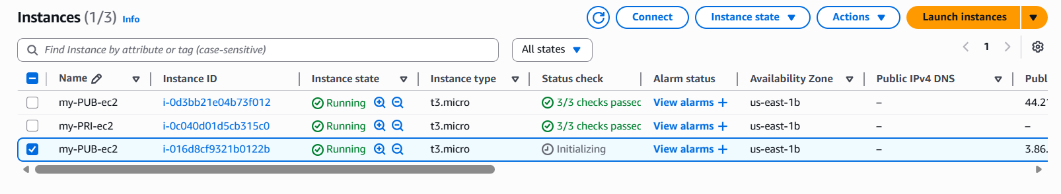

Step 5: Added some fake loads to the CPU utilization and verified that, one more instance getting created.
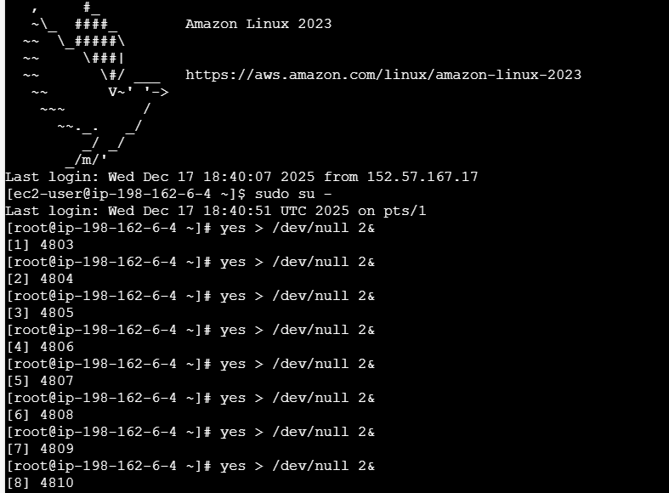
- Monitoring in CloudWatch to see if the graph is up.
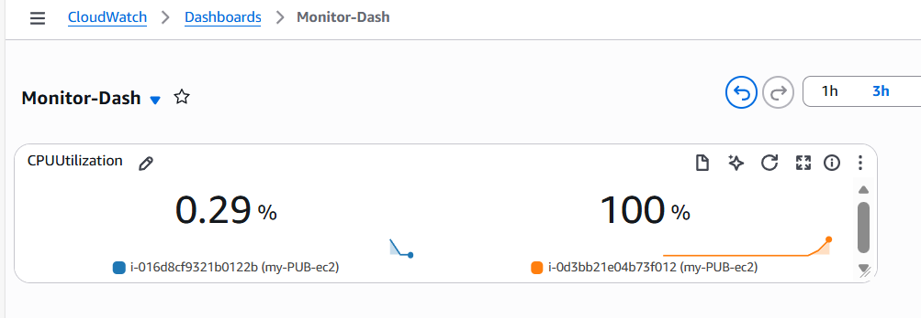
- We went ahead and stopped the instance, to verify if a new instance is getting launched.
- Success- We can see the new instance is launched.
